Viewing Childhood Lead Exposure through a Health Equity Lens
Cook County Department of Public Health
Community Epidemiology and Health Planning Unit
October 2017

Background

Lead is a neurotoxin that has been shown to cause lasting health issues among multiple body systems, causing particular damage to the developing brain.^{1,2} Children are mainly exposed to lead by orally ingesting deteriorated lead-based paint or inhaling lead-contaminated dust.² More than half of the homes built in the United States prior to 1950 contained such paint.² Lead poisoning incidence peaks at about 2 years of age.¹⁻³

Substantial evidence links lead exposure to decreased IQ and ability to concentrate.^{1,2,4-6} Among children enrolled in the Chicago public school system, the risk of failing the reading and math sections of the Illinois Standard Achievement Test increased 32% for every 5 μg/dL increase in blood lead.¹ Moreover, a wealth of data suggests adverse outcomes are irreversible through both pharmacological and nutritional interventions.^{2,7-10}

Early exposure to lead is also shown to have significant downstream effects. Studies have found that upon 50-year follow-up, children with lead poisoning were 7 times more likely to have hypertension and twice as likely to die from cardiovascular disease as compared to their counterparts and that deficits in cognitive ability continued to affect occupational status.^{11,12} Evidence also suggests a lack of effective treatment. No randomized clinical trial suggests chelation, a common treatment to reduce blood lead levels (BLLs), improves outcomes.³ It is estimated that lead-related health care in the United States costs $43.5 billion each year.² In addition to worsened health, approximately $50 billion is lost annually due decreased economic productivity resulting from reduced cognitive potential.¹³

A growing body of evidence citing prolonged health and developmental issues even after low exposure levels resulted in the Advisory Committee on Childhood Lead Poisoning Prevention (ACCLPP) publishing a report in 2012 urging the Centers for Disease Control and Prevention (CDC) to adopt a primary prevention strategy rather than a reactionary protocol for childhood lead exposure.³ Though the CDC recognizes that no lead level is safe for children, a reference level of 10 μg/dL is used for children 1-5 years old.^{3,14}

Like many other public health concerns, risk of lead exposure is not uniformly distributed.² Despite decreases in average blood lead levels, many studies have shown that racial and income disparities persist.³ Krieger et al. determined that geocoding records to either census tract or block group levels can meaningfully identify social determinants of health among children with exposure to lead.¹⁵ While census tracts have shown to predict rates of elevated blood lead levels (EBLLs) among children, there is a need to further analyze cases within dense tracts for social determinant of health predictors.¹⁶

Our Study

Given that there is no safe blood lead level and that exposure is not uniformly distributed, the Community Epidemiology and Health Planning Unit at the Cook County Department of Public Health sought to identify the relationship among place based social determinants of health and elevated blood lead levels among children in suburban Cook County, IL in order to prevent lead exposure.

Our process included analysis at the census block group level and a literature review to identify consistently found social determinants of health lead predictors. Census block groups are the smallest geographic unit reported by the U.S. Census Bureau. Its classification is solely based off of population, containing 600-3,000 people. Due to this census block groups do not adhere to municipality lines. There are 132 municipalities and 3,993 census block groups within suburban Cook County (Figure 1).

After reviewing the literature, four social determinants of health predictors were identified based off of repeated indication in other area-based lead studies. The following were shown to be greater in places where BLLs are higher:
- Percent of individuals living below the poverty line
- Percent of individuals 25 years or older with less than a high school education
- Percent of housing units that are renter occupied
- Percent of homes built before 1950

Methods
In this cross-sectional analysis, we examined the aforementioned area-based social determinant of health measures in children between 1 and 5 years of age reported to the Cook County Department of Public Health (IL) from 2009 to 2013. This time frame was determined so that the most recent census data from 2010 could be used meaningfully to draw inferences about the children’s environment and lead exposure. We only considered the first venous test reported to the county in order to avoid duplicates and ensure that the BLL was accurately measured. Often, when capillary measures are taken, the test may reflect lead on the surface of the child’s skin rather than in their blood; thus, only venous tests were considered. Any child with an address that was invalid or contained a P.O. Box was disqualified from analysis. Our study included 86,087 children, all meeting these inclusion criteria (Figure 1).

Figure 1. Map of Municipalities within Suburban Cook County (left) and Map of Census Block Groups within Suburban Cook County with all Lead Cases between 2009-2013 (right)
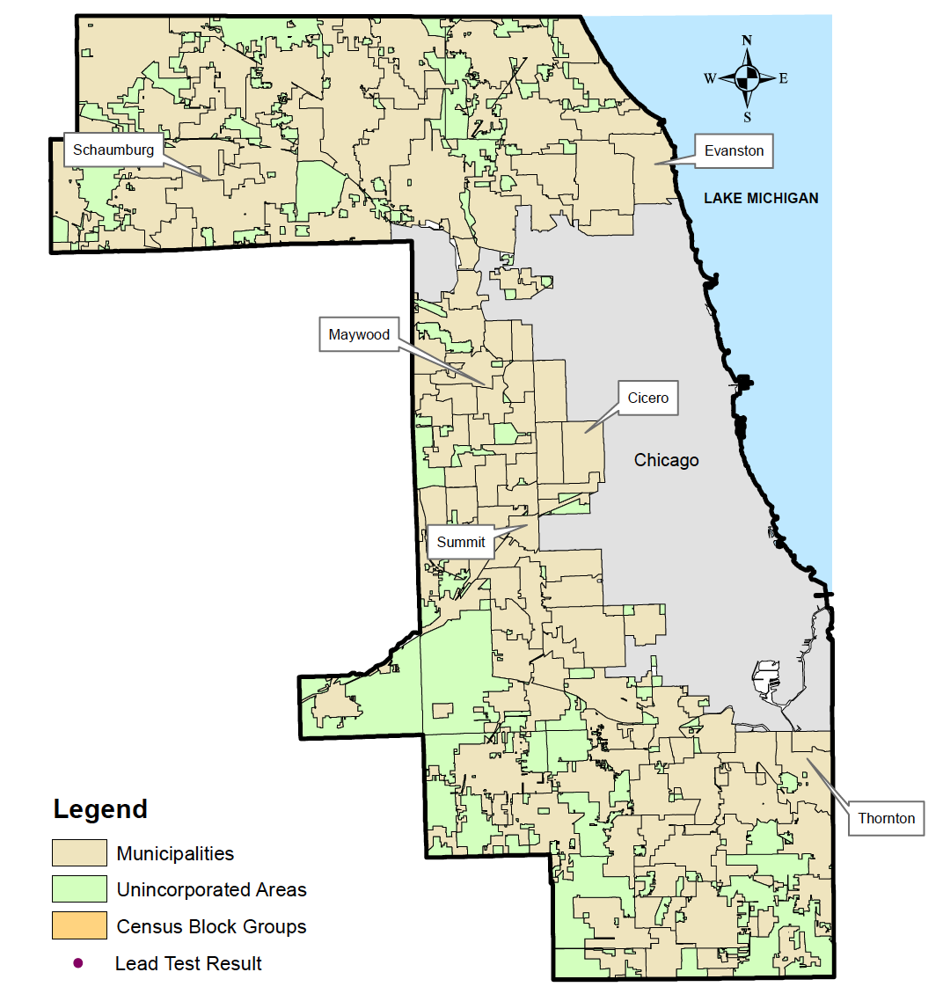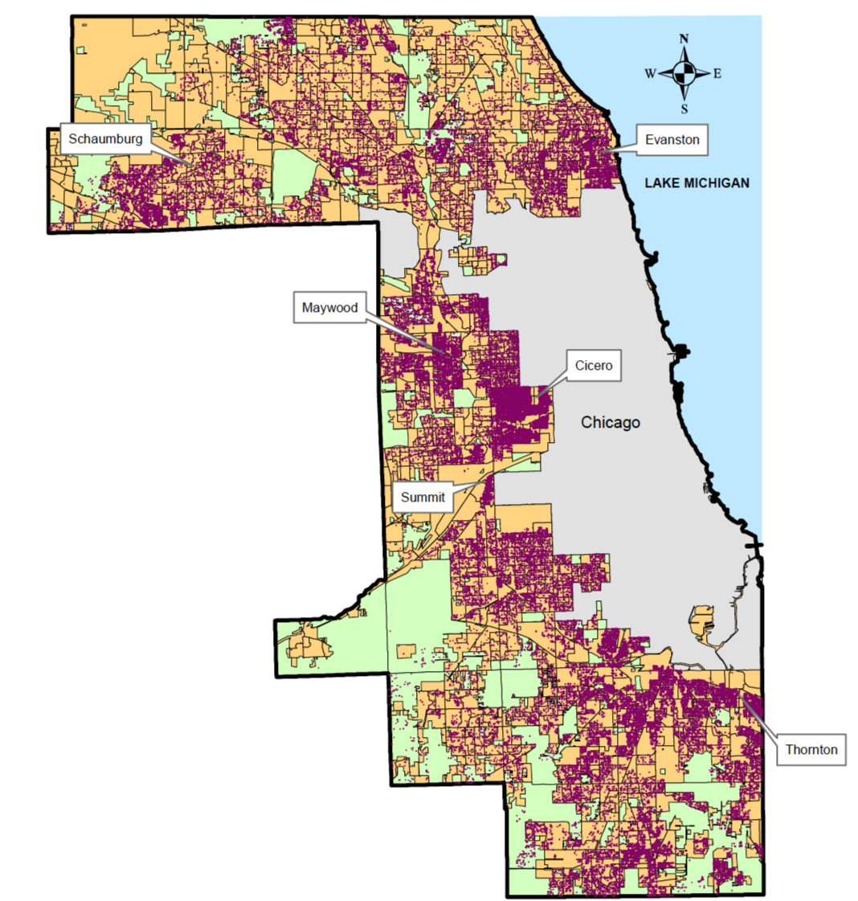

Predictor and population data was obtained from the 2009-2013 American Community Survey and the 2010 U.S. Census, both extracted from the Missouri Census Data Center. These data sets were linked to each other and to each child that was considered for analysis. Software used for this analysis included SAS Enterprise Guide 6.1 (64-bit) and ArcMap 10.2.2.

Analysis
Our large study population (n=86,087) allowed us to perform both a linear regression on each predictor and to examine geographically dense areas with large proportions of high EBLLs in our jurisdiction. A linear regression model is a way to determine a relationship between two variables. For example, if we compare the percent of people living below the poverty line in an area, we expect that same area to contain higher EBLLs. Then if multiple predictors are found to have a linear relationship with EBLL, we would create a multiple regression model that would account for all the predictor relationships with EBLL at the census block group level. When we ran our linear regression analysis, we were not able to fit a regression model for any of the predictors. As in, we did not see the expected linear relationship we had predicted: our results were inconclusive. We then sought to confirm this lack of relationship visually.

Upon visual analysis, we confirmed our mathematical results. For all the census block groups within Cook County, we categorized each into three categories (Low, Medium, or High) based off the amount of EBLL in that area. Areas that are categorized as red had children with higher EBLL than in census block groups that are colored green. The same categorization was applied to a map depicting poverty in suburban Cook County. We visually compared the proportion of high tests in an area to each predictor. For the example below, we used poverty (Figure 2). Looking to see if the colors consistently match on both maps allowed us to visually inspect a lack of linear relationship. Looking at the census block groups in blue, we would expect that in the same places, where there is a high proportion of EBLL, that poverty would also be severe. We can see that this is not the case. Alternatively, looking at the purple circle in Figure 2, we can see that some census block groups do in fact match in color. This inconsistency in relationship, points to the fact that there is not a clear linear relationship. However, while our analysis did not allow our department to identify EBLL predictors, we were in fact able to track kids with higher EBLL.

Figure 2. Selected Census Block Groups, Western District: Comparison of Percent High EBLL Tests to Percent Living Below the Poverty Line
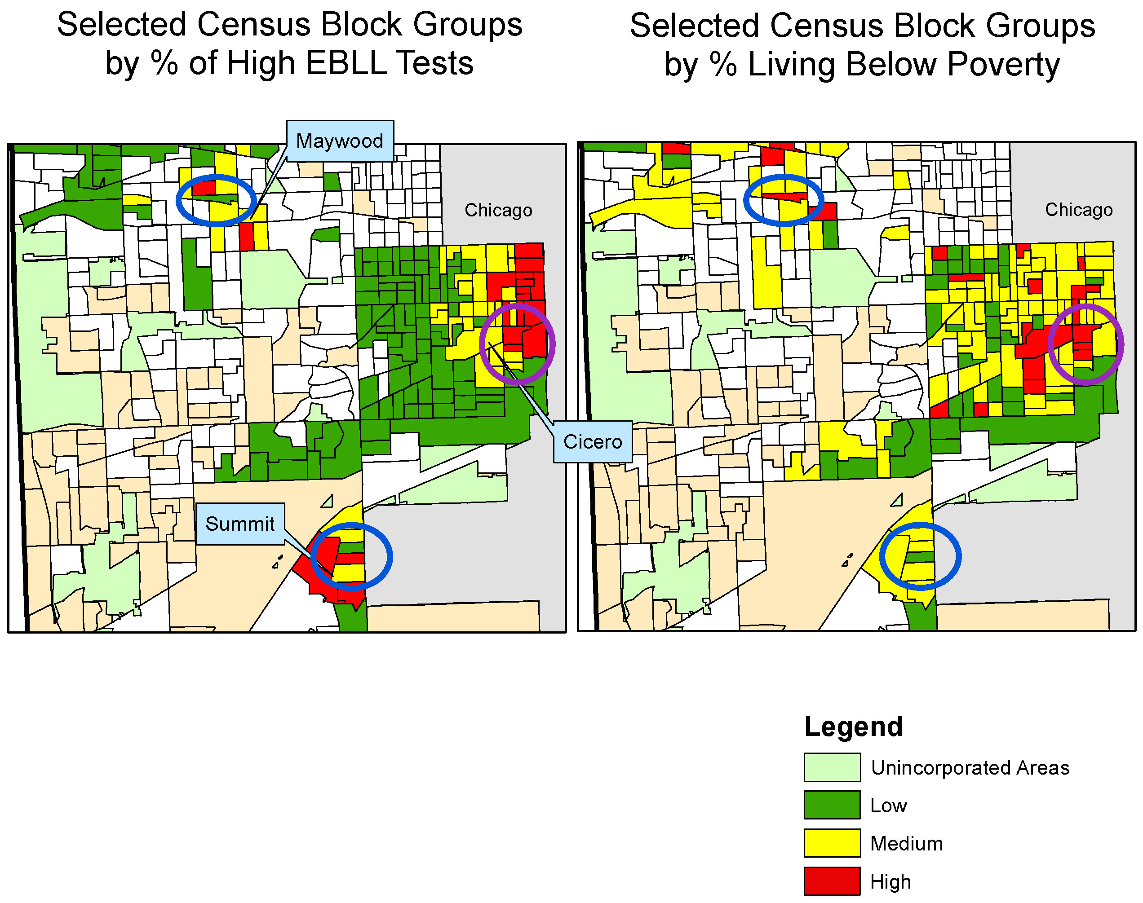

Given that we already had the address and lead test result information for each child in our study, we categorized them into high and low test results and mapped them in order to identify dense areas of high EBLLs. For this additional analysis, we considered any child with a test result of less than 5 μg/dL to be a “low test result” and any child with a 5 μg/dL or greater result to be a “high test result.” For suburban Cook County, there were 79,250 low test results and 6,837 high test results (Figure 3). The high test results account for 7.9% of all tests in suburban Cook County. The national average, based on 2007-2010 NHANES, data is 2.6%.¹⁷ Suburban Cook County has 3 times the national estimate of children ages 1-5 with BLLs at or above 5 μg/dL.

Figure 3. Map of Suburban Cook County with High and Low Test Results
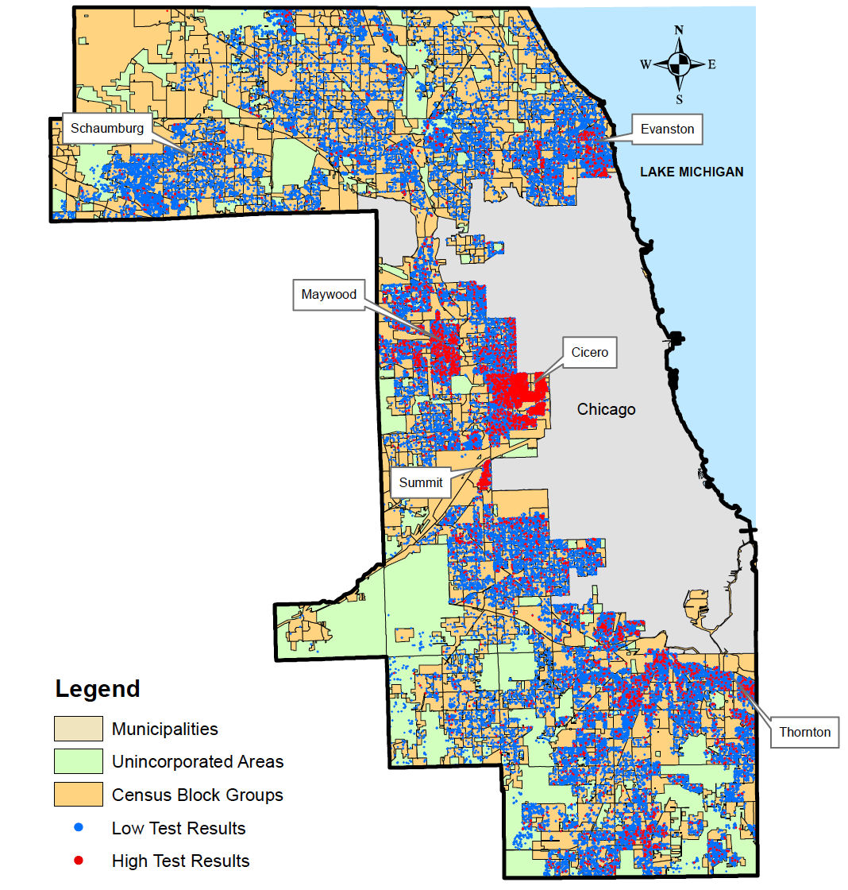

Based off of the geographical analysis of each high test result in our jurisdiction, the Western district was identified to have the most dense areas of high EBLL results. Upon further analysis we noticed that within the Western district, high tests were contained in small geographic areas. We found that nearly half of all the high tests in the entire county were concentrated in just 19 census block groups within this district. Moreover, the 19 census block groups were contained within only 3 municipalities: Cicero (14 block groups), Summit (3 block groups), and Maywood (2 block groups). These selected areas are highlighted in Figure 4 (see below).

Figure 4. Census Block Groups Identified for High Proportion of High Tests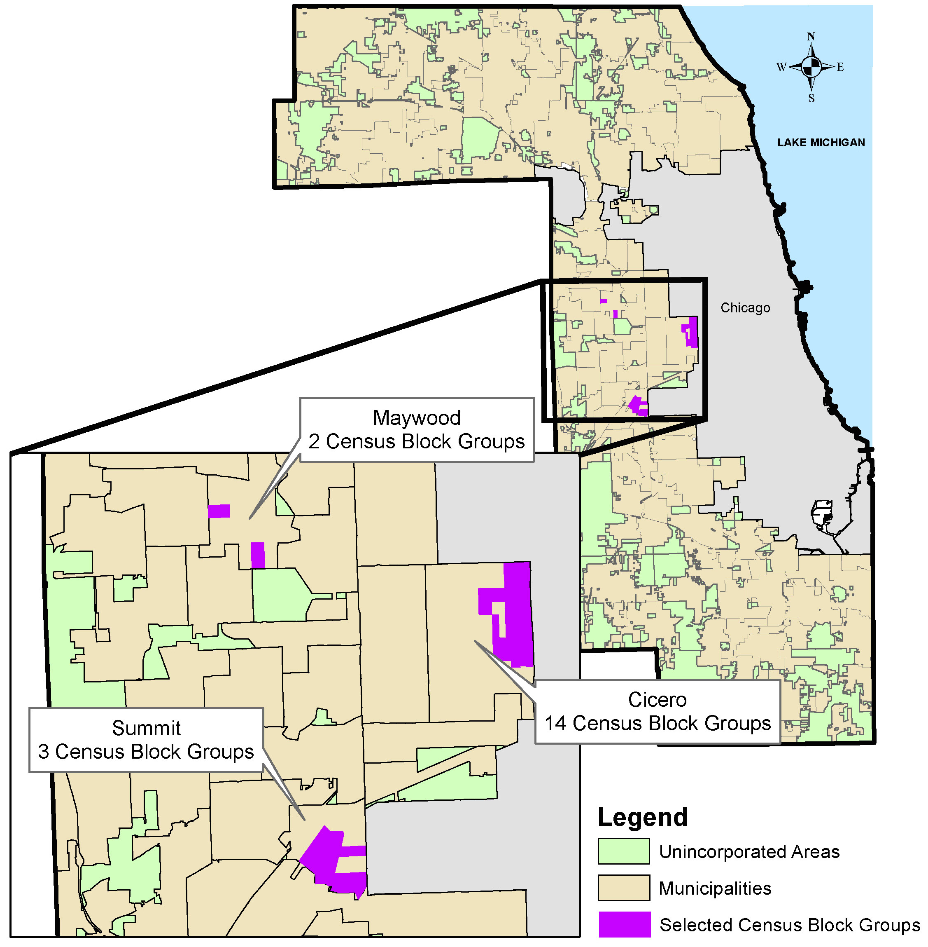

In order to understand the characteristics of each area, we grouped the selected 19 census block groups by the municipality they are located in (Figure 5).

Figure 5. Comparison of 3 Selected Municipalities: Cicero, Summit, and Maywood, IL

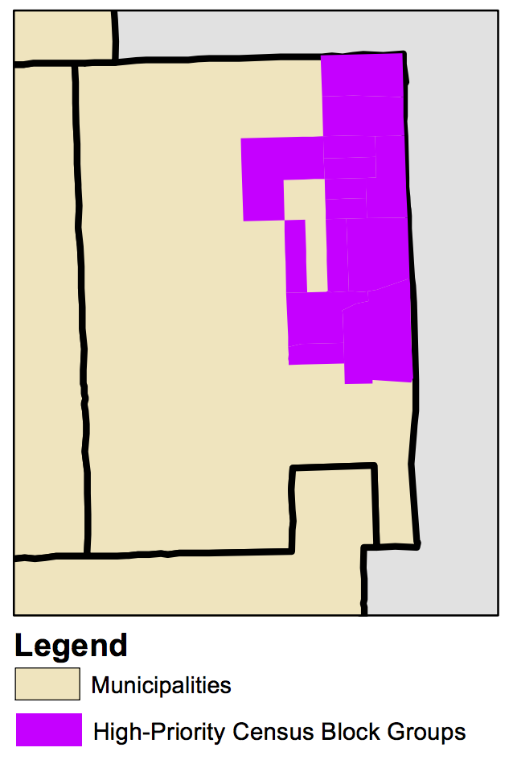
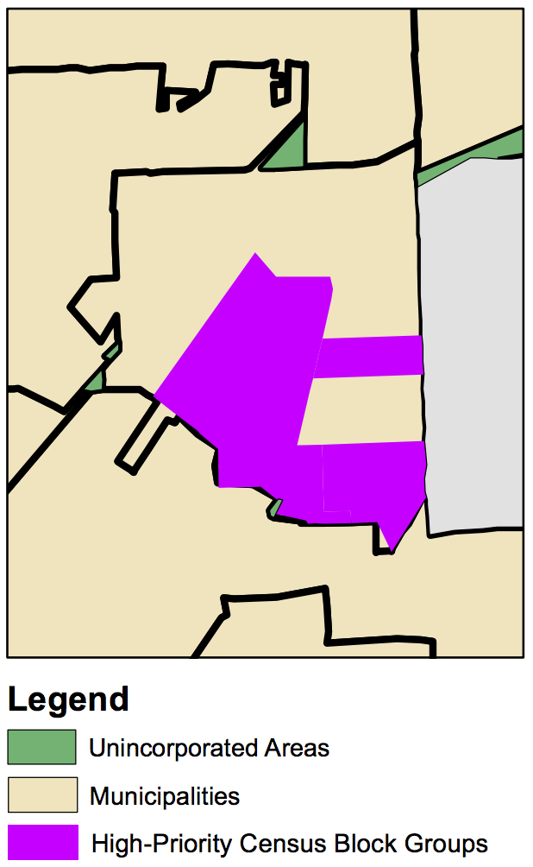
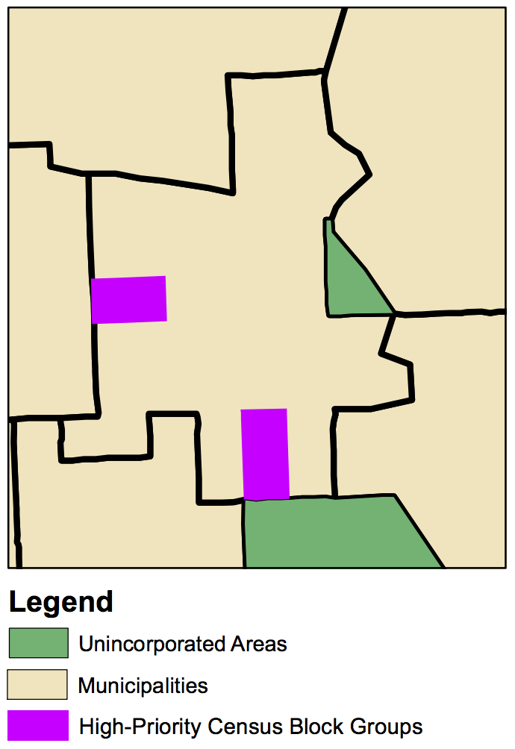
~485 High Test Kids/Year
14 Census Block Groups

Population: 18,113
Under 5 Pop.: 1,549
1.36 square miles
4,527 housing units
57.9% renter occupied
90.7% Hispanic
~74 High Test Kids/Year
3 Census Block Groups

Population: 4,797
Under 5 Pop.: 358
0.89 square miles
1,447 housing units
45.9% renter occupied
64.1% Hispanic
~27 High Test Kids/Year
2 Census Block Groups

Population: 2,617
Under 5 Pop.: 145
0.23 square miles
898 housing units
31% renter occupied
85.8% Black (Non-Hispanic)
Cicero
Summit
Maywood
Total
2,920 High Test Kids over 5 years (~584/Year)
19 Census Block Groups
Population: 25,527
Under 5 Pop.: 2,052
2.48 square miles
6,838 housing units
52% renter occupied
77.3 % Hispanic
14.8 % Black (Non-Hispanic)
Cicero +
Summit +
Maywood
Of the three municipalities, Cicero has by far the largest amount of children with high test results. Of the 18,113 people living in the 14 census block groups identified, 1,549 of them are under the age of 5, of which nearly one-third (485 kids) have a BLL at or above 5 μg/dL each year. Of the 4,527 housing units in the 1.36 square miles identified, 57.9% are renter occupied and consist of a 90.7% Hispanic resident population.

The three census block groups identified in Summit contain 4,797 individuals, of which 358 are less than 5 years old. Of the 358 children at-risk, about 74 of them will have a 5 μg/dL or above BLL test result each year. These children live in a little less than one square mile, which contains 1,447 housing units. These communities are also predominantly Hispanic.

The two selected census block groups in Maywood contain 2,617 people, with 145 of them being children under 5 years. Of these kids, about 27 of them will have a high test result each year. They live in under one-fourth of a square mile. The percentage of renter occupied housing is much less than in Cicero and Summit at 31% and its community is predominantly black (non-Hispanic).

We also looked at the breakdown of predictors for our three selected municipalities (Figure 6). While the percent of individuals living below the poverty line was similar across all Cicero, Summit, and Maywood (~20%), the percentage of homes built before 1950, housing units that are renter occupied, and individuals with less than a high school education was highest in Cicero, IL.

Figure 6. Social Determinants of Health Predictor Breakdown by Selected Municipality

Looking at the children with high test results, population, housing stock, race and ethnicity, and social determinants of health predictors within the selected census block groups and municipalities allows us to understand the populations most affected within these areas.

Limitations

As with all studies, there were limitations to our methods and analysis. Our study did not allow us to predict where there may be higher EBLLs, but it did allow us to track where high EBLLs are historically. This said, we hope to explore different methods of analysis in order to see if a prediction model exists for our jurisdiction. During our analysis we discovered an anomaly: some census block groups with no children under the age of 5 had reported test results and other census block groups with many children under the age of 5 had no reported test results. These observations can point to testing bias, reporting discrepancies, or frequent moving within certain areas of suburban Cook County.

Recommendations

Based off of our findings of this study and understanding its limitations, we created recommendations for the suburban Cook County lead program. The impact of each recommendation was also evaluated. Our four recommendations, based on this analysis, are as follows:
- Currently the HUD (Housing and Urban Development) grant in suburban Cook County includes both Maywood and Cicero. We recommend exploring including Summit as a priority area in this grant. Doing so would focus abatement efforts on the 74 children per year with high test results in the 3 census blocks identified within this municipality.
- We recommend focusing outreach efforts on the 19 census block groups with the highest proportion of high tests identified in Cicero, Summit and Maywood and to the medical providers serving the residents in these blocks. This will provide the 25,527 residents with lead education, which can increase screening rates and promote prevention at the individual level.
- When the suburban Cook County lead program expands to intervene at lower EBLLs, we recommend focusing this roll-out on the identified 19 census block groups. This would emphasize our lead management efforts on the children most affected by lead exposure within small geographic areas.
- Finally, we recommend promoting policy, starting with priority municipalities, regarding lead poisoning prevention strategies within their borders. This can include, but is not limited to, policy regarding health building codes, prospective rental inspection, window replacement, and RRP (renovation, repair, and painting certification) enforcement. Doing so can further prevention efforts at the municipality level.

Informing our policies using relevant data can allow our lead program to do even more good for the people and children in our jurisdiction. This analysis has the ability to affirm any program initiatives that are currently underway and to explore efficient areas for program expansion. In addition to program recommendations, we encourage further research in the fields of small-area analysis and lead exposure moving forward.

Acknowledgements

The authors of this report are Nirali Chauhan and Buddy Bates. This work would not be possible without the support of the Cook County Department of Public Health, Alatrum Institute, or Maternal and Child Health Bureau within the U.S. Department of Health and Human Services.

References

1. Evens A, Hryhorczuk D, Lanphear BP, et al. The impact of low-level lead toxicity on school performance among children in the Chicago Public Schools: a population-based retrospective cohort study. Environmental Health. 2015;14(1):21.
2. Chandran L, Cataldo R. Lead Poisoning: Basics and New Developments. Pediatrics in Review. 2010;31(10):399-405.
3. Low Level Lead Exposure Harms Children: A Renewed Call for Primary Prevention. Advisory Committee on Childhood Lead Poisoning Prevention of the Centers for Disease Control and Prevention;2012.
4. Healey N, Jones-Otazo H, Walker M, Knafla A. Toxicological Review and Recommended Toxicological Reference Values for Environmental Lead Exposure in Canada. Final Report. Prepared under contract to Health Canada. Prepared for the Contaminated Sites Division, Safe Environments Directorate, Healthy Envrionment and Consumer Safety Branch, Health Canada. Ottawa 2010.
5. Lanphear BP, Homung R, Khoury J, et al. Low-level envrionmental lead exposure and children’s intellectual function: an international pooled analysis Envrion Health Perspect. 2005;113(7):894-899.
6. Chiodo LM, Covington C, Sokol RJ, et al. Blood lead levels and specific attention effects in young children Neurotoxicology and Teratology. 2007;29(5):538-546.
7. Kordas K, Canfield RL, Lopez P, et al. Deficits in cognitive function and achievement in Mexican first-graders with low blood lead concentrations. Environmental Research. 2006;100(3):371-386.
8. Rico JA, Kordas K, Lopez P, et al. Efficacy of Iron and/or Zinc Supplementation on Cognitive Performance of Lead-Exposed Mexican Schoolchildren: A Randomized, Placebo-Controlled Trial Pediatrics 2006;117(3):e518-e527.
9. Rogan WJ, Dietrich KN, WAre JH, et al. The Effect of Chelation Therapy with Succimer on Neuropsychological Development in Children Exposed to Lead. The New England Journal of Medicine. 2001;344:1421-1426.
10. Dietrich K, Ware J, Salganik M, et al. Effect of chelation therapy on the neuropsychological and behavioral development of lead-exposed children after school entry. Pediatrics. 2004;114(1):19-26.
11. Hu H. A 50-Year Follow-up of Childhodd Plumbism Hypertension: Renal Function, and Hemoglobin Levels Among Survivors. Am J Dis Child. 1991;145(6):681-687.
12. White RF, Diamond R, Proctor S, Morey C, Hu H. Residual cognitive deficits 50 years after lead poisoning during childhood Occupational and Environmental Medicine. 1993;50:613-622.
13. Gould E. Childhood Lead Poisioning: Conservative Estimates of the Social and Economic Benefits of Lead Hazard Control Environ Health Perspect. 2009;117(7):1162-1167.
14. Lead. 2017; https://www.cdc.gov/nceh/lead/. Accessed August 14, 2017.
15. Krieger N, Chen JT, Waterman PD, Soobader M-J, Subramanian SV, Carson R. Choosing area based socioeconomic measures to monitor social inequities in low birth weight and childhood lead poisoning: The Public Healht Disparities Geocoding Project (US). J Epidemiol Community Health. 2003(57):186-199.
16. Kaplowitz S, Perlstadt H, Post L. Comparing lead poisoning risk assessment methods: census block group characteristics vs. zip codes as predictors. Public Health Rep. 2010;125:234-245.
17. Wheeler W, Brown MJ. Blood Lead Levels in Children Aged 1–5 Years — United States, 1999–2010. Centers for Disease Control and Prevention. https://www.cdc.gov/mmwr/preview/mmwrhtml/mm6213a3.htm. Published April 5, 2013. Accessed October 24, 2017

