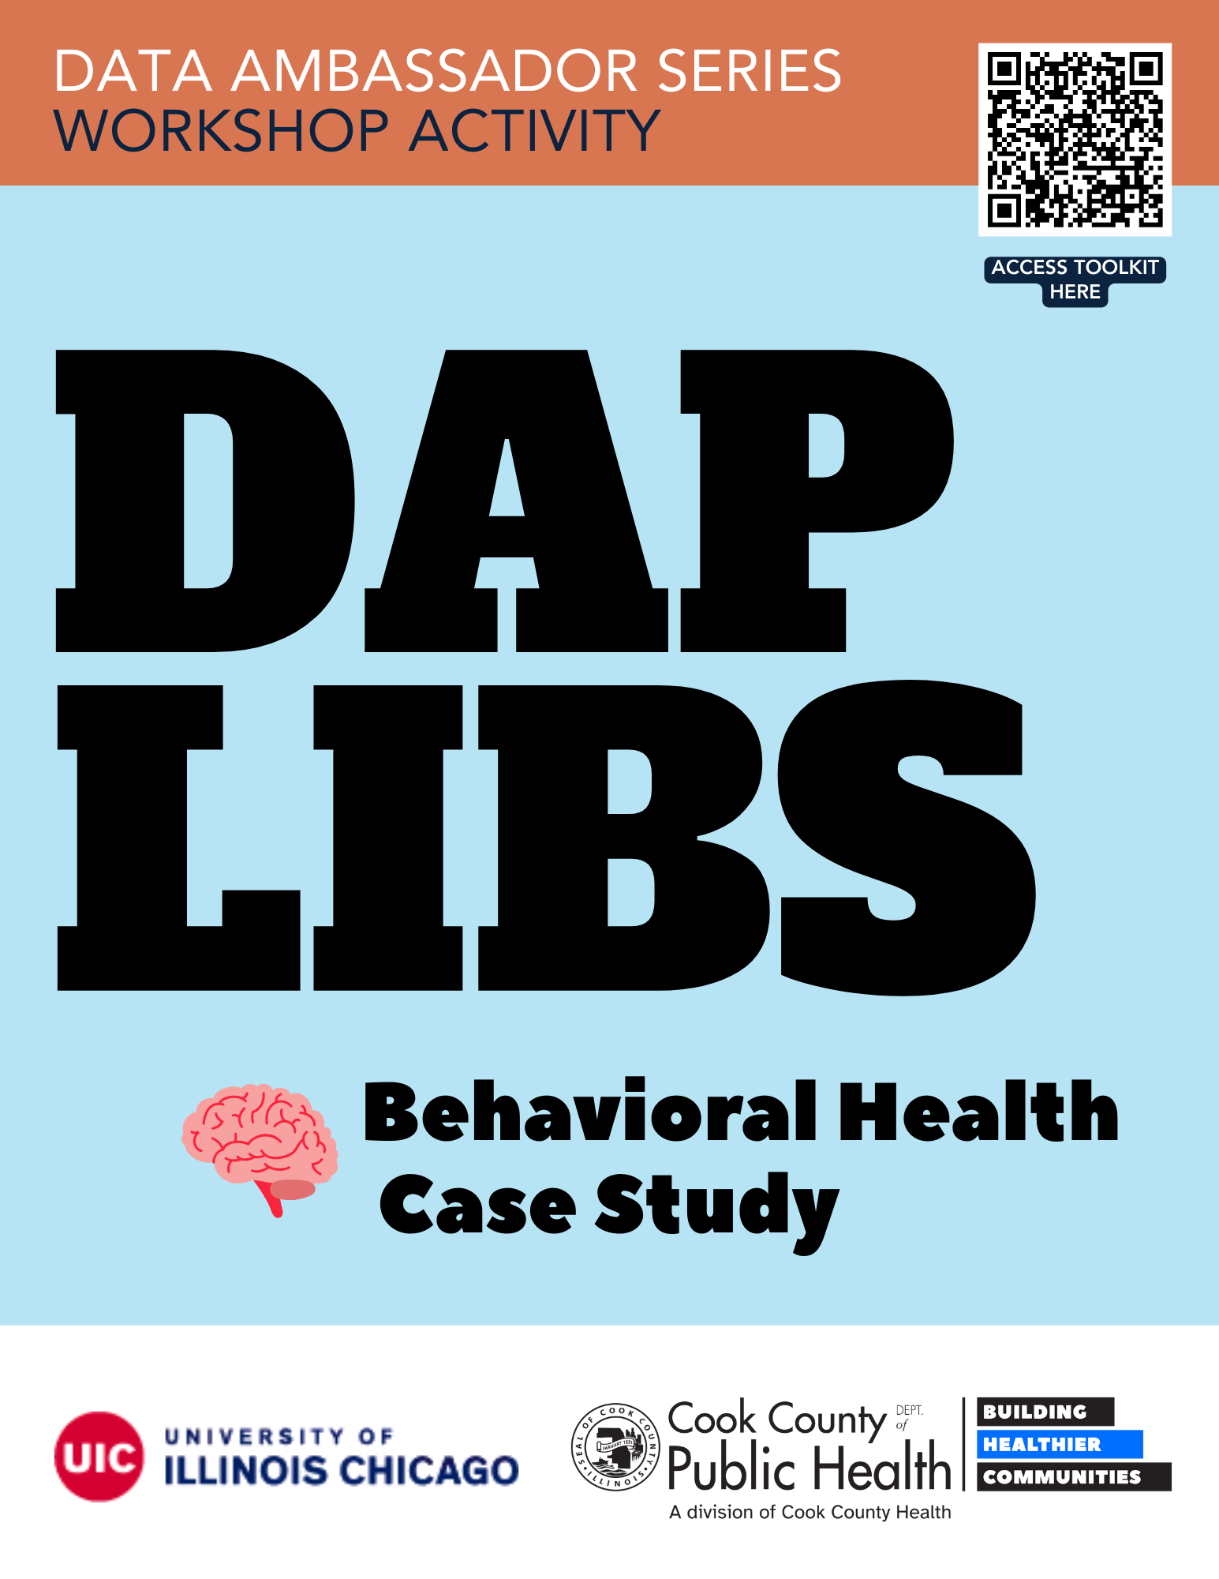

Cara works as a grant coordinator at ABC Crisis Services. Cara is writing a grant proposal for a program that addresses adult mental health crisis care in __________________. They hope to capture risk of crisis events based on location and demographic.

Cara goes to the Cook County Health Atlas Data Dictionary to search for indicators related to mental health crisis and prevention. Some key words searched included “behavioral health” and “ED visit.”

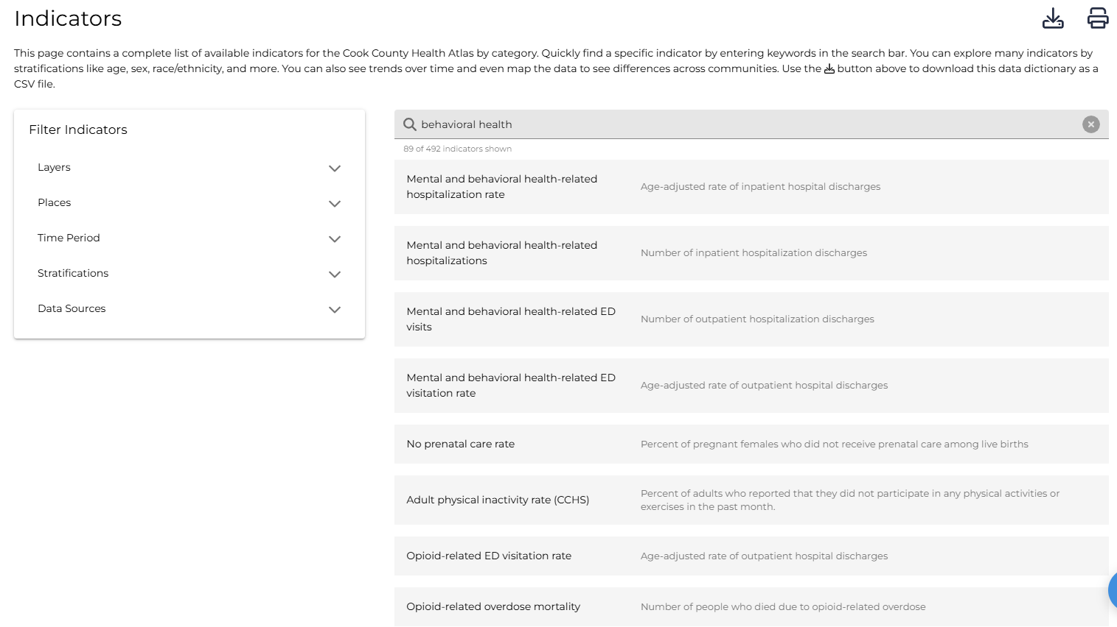

They identify the following indicators that could support their crisis care work:

- Mental and behavioral health-related ED visitation rate
- Mental and substance use-related ED visitation rate
- Mood and depressive disorder ED visitation rate
- Opioid-related ED visitation rate
- Intentional self-harm ED Visit rate

Cara decides to use 2 indicators to include in the grant application:
- Mental and behavioral health-related ED visitation rate
- Opioid-related ED visitation rate

Cara finds a bar chart on Mental and behavioral health-related ED visitation rate, which is broken down by race and ethnicity.

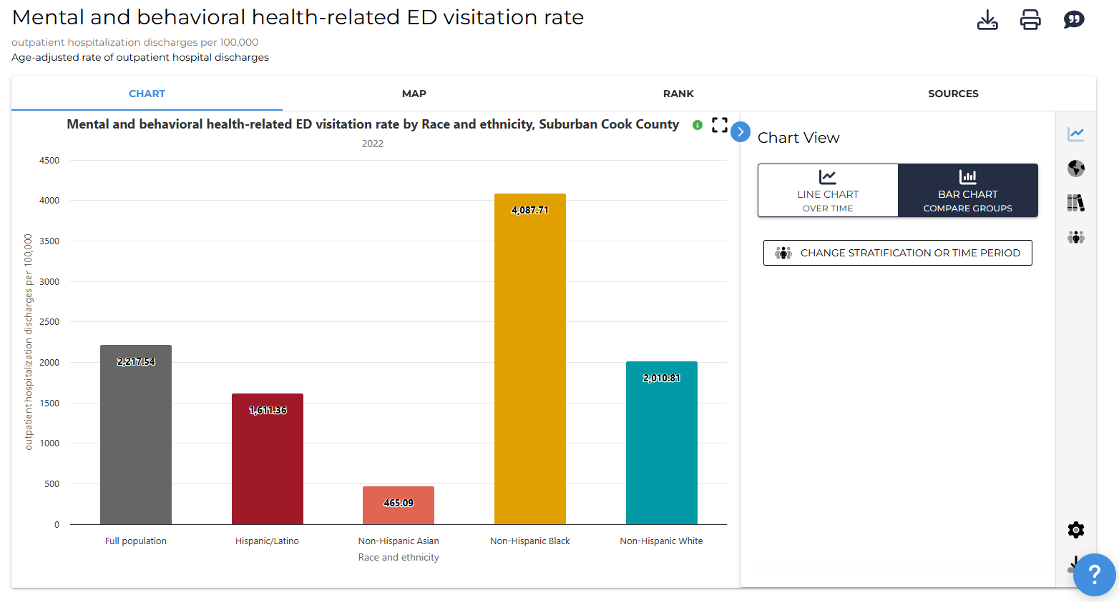

____________ shows the highest rate of Mental and behavioral health-related ED visitation with a rate of ___________ per 100,000 people. In comparison, ____________ shows the lowest rate under this indicator with a rate of __________ per 100,000 people.

Next, they click “Line Chart” and examine how Mental and behavioral health-related ED visitation rates have changed over time (2016-2022) among all suburban Cook County, as well as among specific racial/ethnic groups.

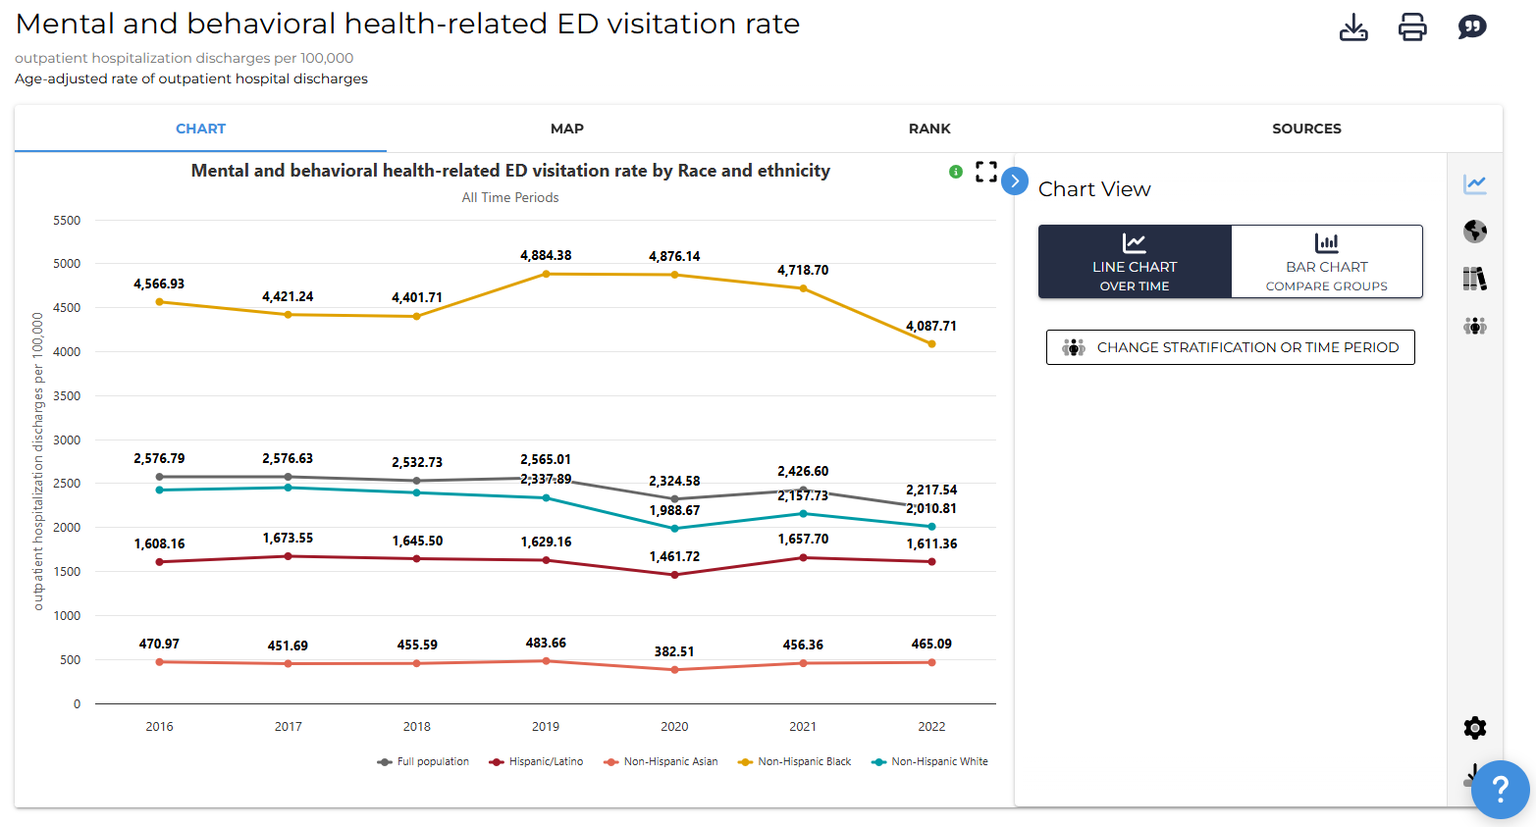

They find that, since 2016, rates have generally ____________ for the full suburban Cook County population. They also noticed that ____________has a _________rate compared to the full population.

Cara then clicks to view the map to understand this rate in ____________; however, the data is only visualized by zip code.

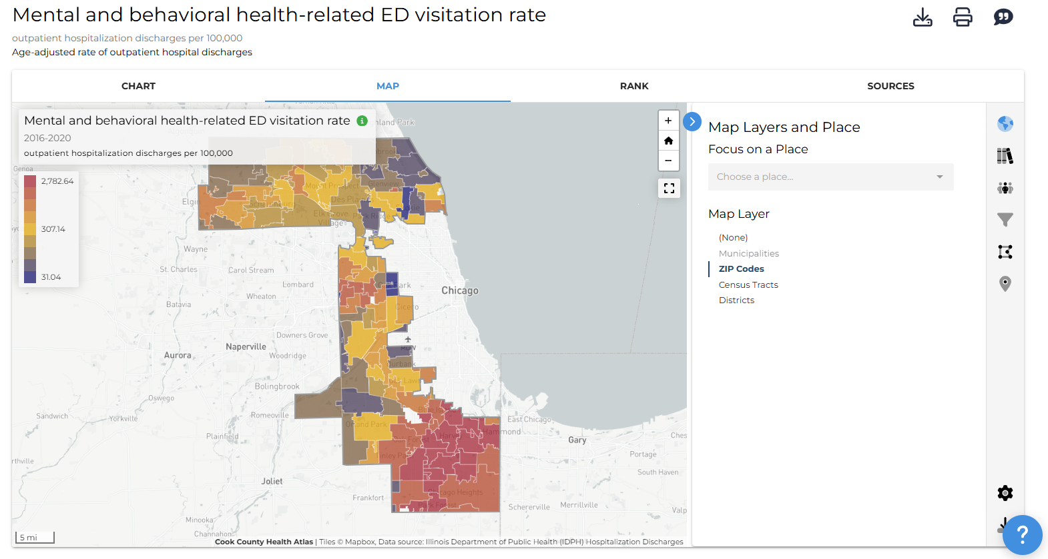

They click on _______to focus on this community for their analysis. Then, she views a map and realizes that this indicator is visualized by municipalities.

They find that in zip code ______________ outpatient hospitalization discharges occurred at a rate of ____________ per 100,000 between 2016-2020.

After looking at Mental and behavioral health-related ED visitation rates, Cara is curious to learn more about Opioid-related ED visitation rates in suburban Cook County. They identify a bar chart on Opioid-related ED visitation rate, which is broken down by race and ethnicity.

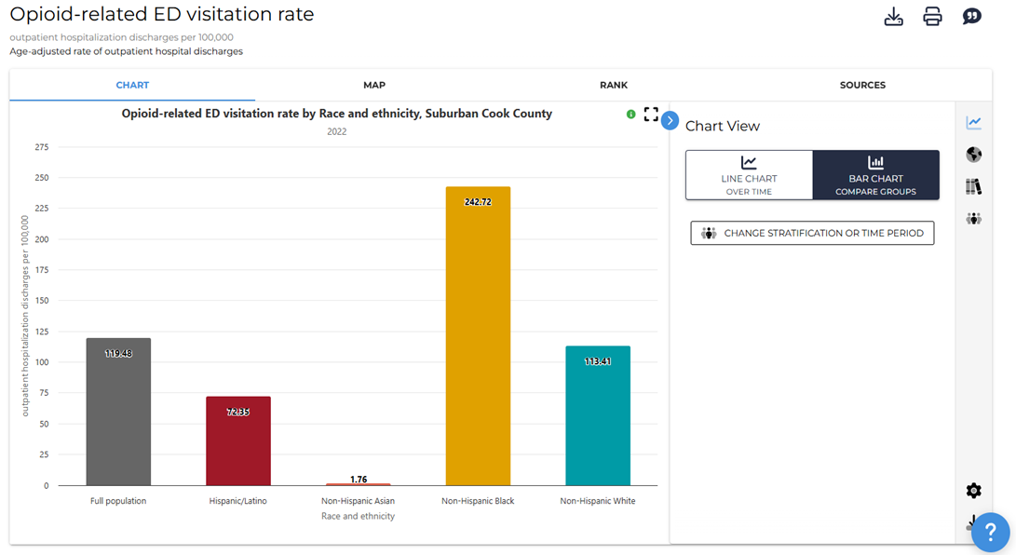

They observe that the ___________ population shows the highest rate under this indicator, with a rate of _______ per 100,000 people.

In comparison, the ____________ population shows the lowest rate under this indicator, with a rate of _______ per 100,000 people. This is ________________ than the rate for suburban Cook County.

Then, they click “Line Chart” and examine how Opioid-related ED visitation rates have changed over time (2010-2022) among all of suburban Cook County, as well as among specific racial/ethnic groups.

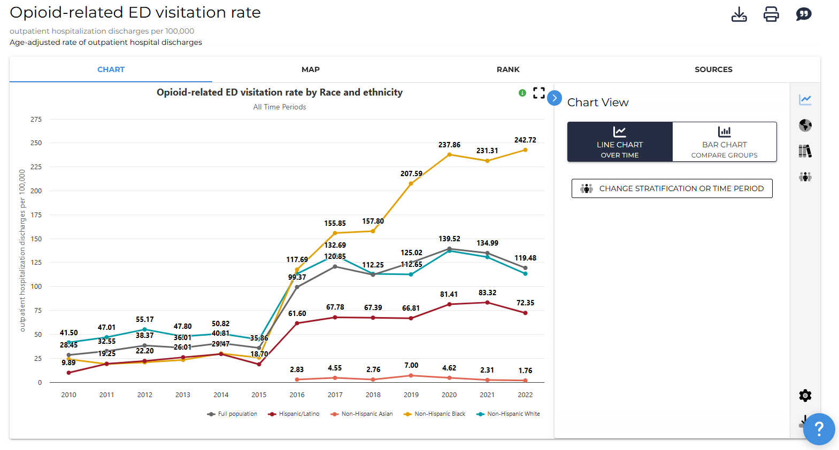

They find that, since 2010, rates have generally ___________among all suburban Cook County. They also noticed ______________.

Cara then clicks and pulls up a map. Looking at the available map, Cara is interested in opioid-related ED visitation rates in ___________.

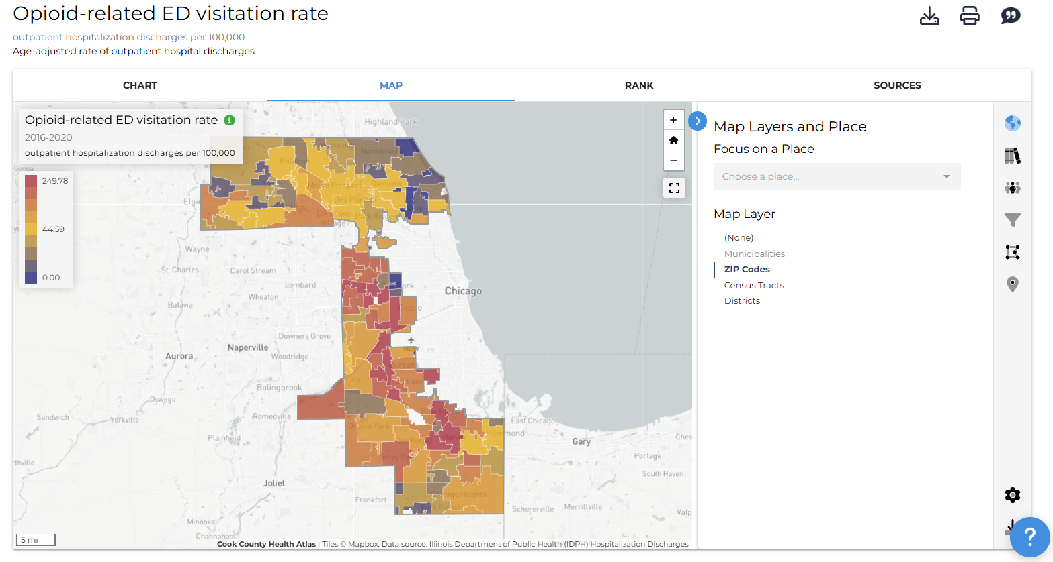

Similar to the Mental and behavioral health-related ED visitation rate, this data is broken down by zip code only.

The most recent Opioid-related ED visitation rate(s) in __________ are ________ per 100,000 people. This is _______than the rate for all suburban Cook County, which is ________ per 100,000 people.

The data Cara captured demonstrates a need for adult crisis intervention and follow-up treatment in their community. This strengthens ABC Crisis Services’ request for additional funding to support their program.

Questions for Discussion
- What did you find surprising about the data?
- Did you identify any disparities in the data? If yes, among which groups?
- How could this type of data support your work (i.e., programming, grant applications)?
- What other indicators could be helpful to better understand the crisis care system?

For more help with this activity, see a step-by-step tutorial here: Tutorial

