
Sam, a program coordinator with “Quality Air Inc.,” is interested in developing an educational campaign to address asthma-related disparities in suburban Cook County. They plan to promote their educational materials through billboards and other advertisements while also advocating for better air quality conditions but would like to identify areas that are most impacted.
Sam searches the Cook County Health Atlas Data Dictionary for indicators related to asthma and other environmental conditions. They find 9 different indicators to examine:

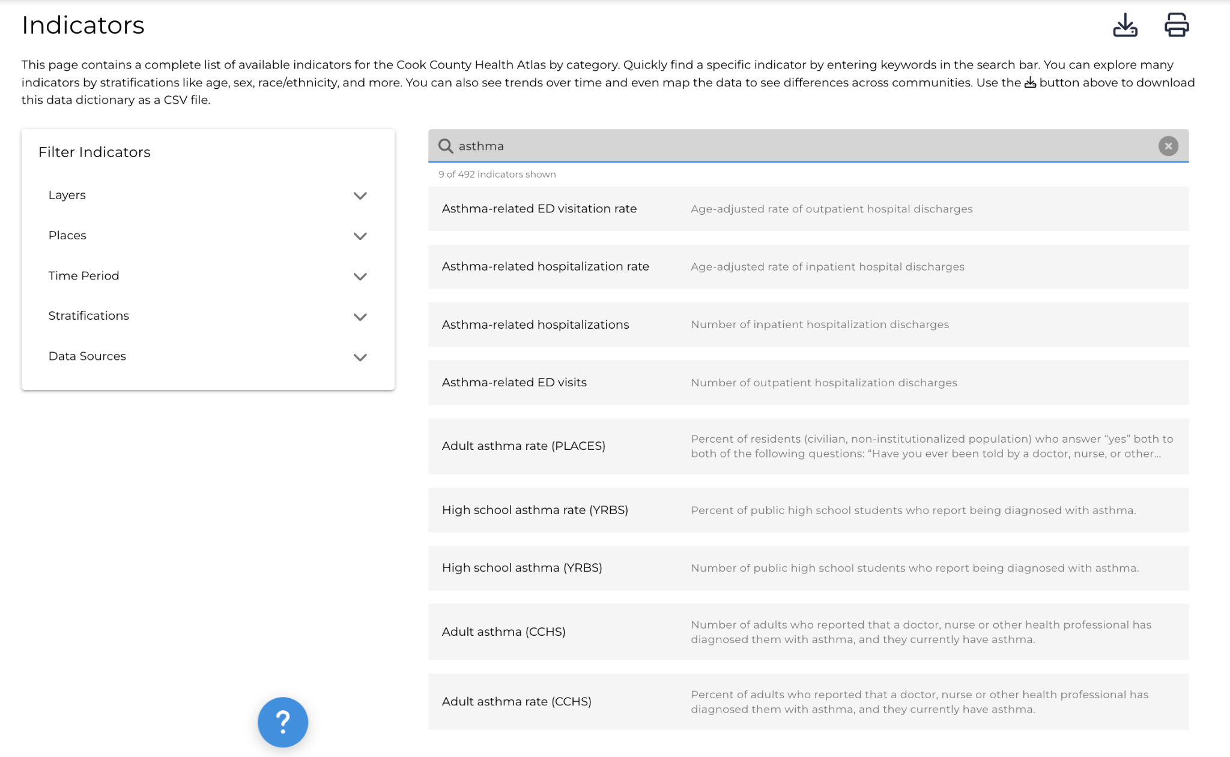
Sam decides to use the two following indicators for their educational campaigns: Asthma-related hospitalization rate and Adult asthma rate (CCHS)
- Asthma-related ED visitation rate
- Asthma-related hospitalization rate ✅
- Asthma-related hospitalizations
- Asthma-related ED visits
- Adult asthma rate (PLACES) ✅
- High school asthma rate (YRBS)
- High school asthma (YRBS)
- Adult asthma (CCHS)
- Adult asthma rate (CCHS)

Sam notes the data sources for these indicators include the following:
- PLACES - Centers for Disease Control (CDC), Behavioral Risk Factor Surveillance System
- YRBS - Youth-Risk Behavioral Survey
- CCHS - Cook County Health Survey

First, Sam searches the asthma-related hospitalization rate indicator and finds a bar chart of hospitalizations by race/ethnicity in all suburban Cook County for 2022.
They notice that the ___________ population has a _____ per 100,0000, which is the highest rate across all racial/ethnic groups. The lowest burden is among ___________ population, which has a rate of _____ per 100,000 persons.
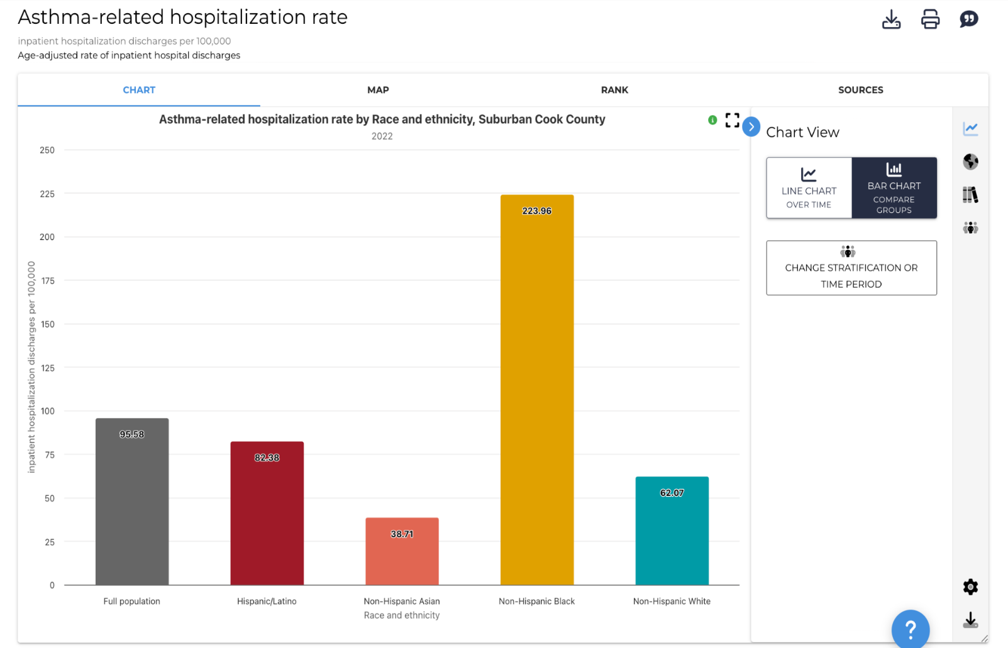

Next, Sam clicks and opens a line chart showing changes in asthma-related hospitalization for all time periods. Among the full population, the asthma-related hospitalization rate has increased from _________to ________ from 2020 to 2022.

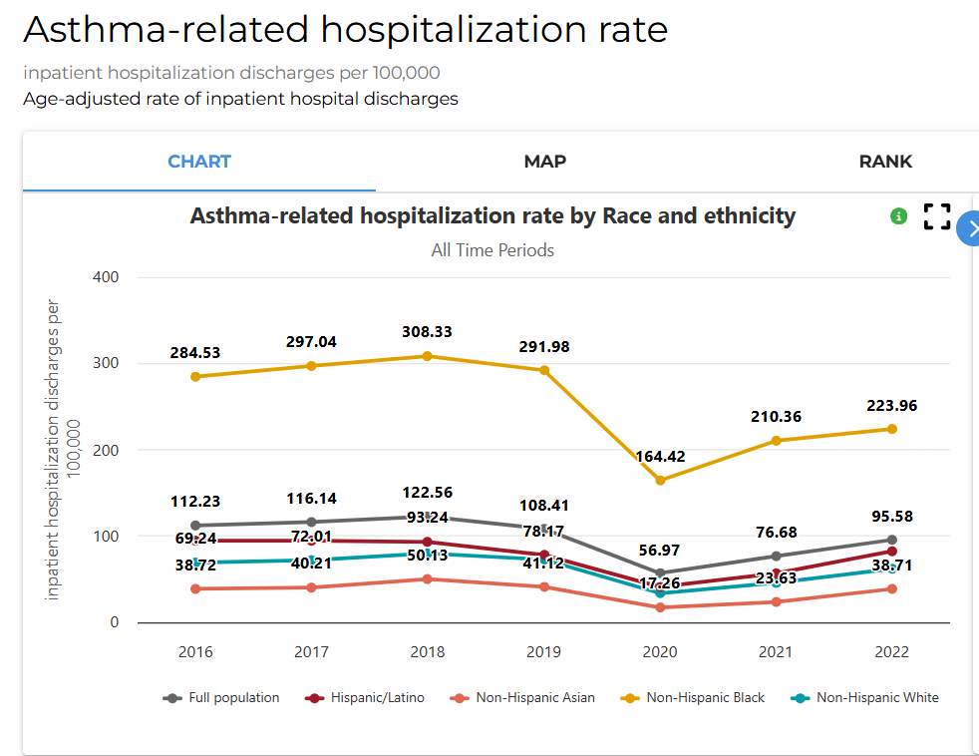

Sam is interested in how asthma hospitalization rates have changed over time, and notices that all racial/ethnicities groups have experienced a/an _________ in asthma-related hospitalization rates since 2020.

Sam clicks and opens the map visualization. Overall, they notice that the highest burden of asthma-related hospitalizations is located in the _________ and _________ regions of suburban Cook County. They decide to promote their new educational campaign in these areas.
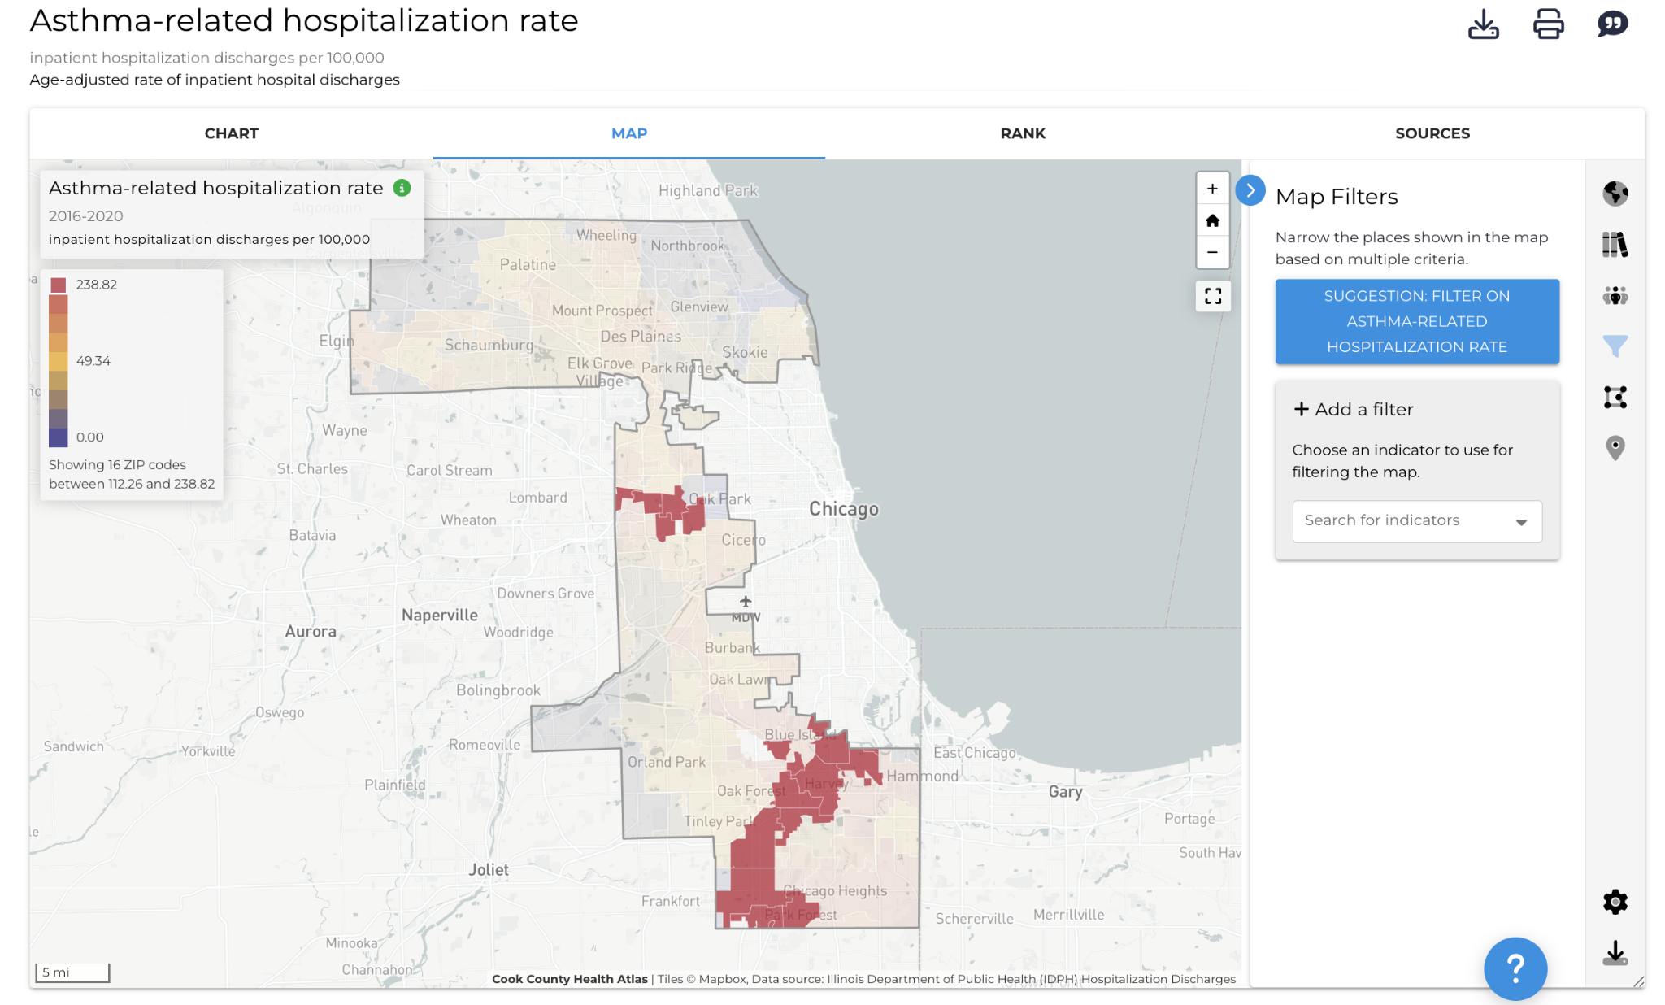

After looking at asthma-related hospitalization rates, Sam wants to know more about people who have been formally diagnosed with asthma by a healthcare professional. Sam searches the adult asthma rate (CCHS) indicator and finds that __________ persons residing in suburban Cook County have the largest asthma diagnosis with _________.
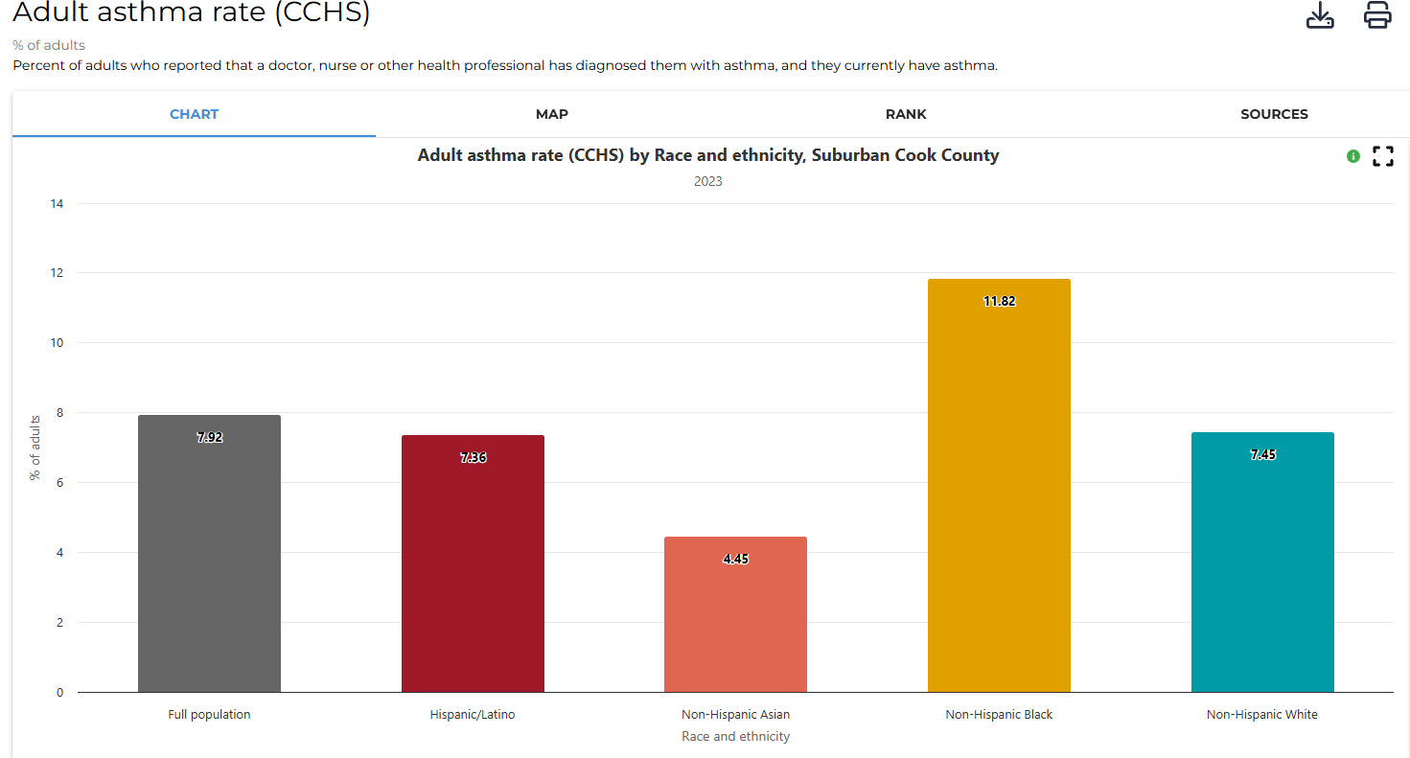

Jasmine, a health educator from “Healthy Hearts Illinois” is interested in delivering free blood pressure screenings and organizing a fresh fruits and vegetables giveaway to address heart health in suburban Cook County. Her organization plans to recruit farmers’ markets from across the state to promote meal preparation and healthy eating for this event.
Jasmine visits the Cook County Health Atlas to search for indicators such as stroke mortality and other hospitalization outcomes. The following indicators were identified:
- Stroke mortality rate ✅
- Stroke-related hospitalization rate
- Stroke-related ED visits
- Stroke-related ED visitation rate
- Stroke-related hospitalization rate✅
- Stroke (PLACES)
- Stroke-related hospitalizations

Jasmine chooses the following indicators for her educational campaigns: Stroke mortality rate and Stroke-related hospitalization rate

First, Jasmine searches for the stroke mortality rate indicator and finds a bar chart of hospitalizations by race/ethnicity in all suburban Cook County.
In _______, she notices that the __________ population has a rate of _________per 100,0000 persons, which is the highest rate across all racial/ethnic groups.
The lowest burden is among ___________ population, who has a rate of _______per 100,000 persons.

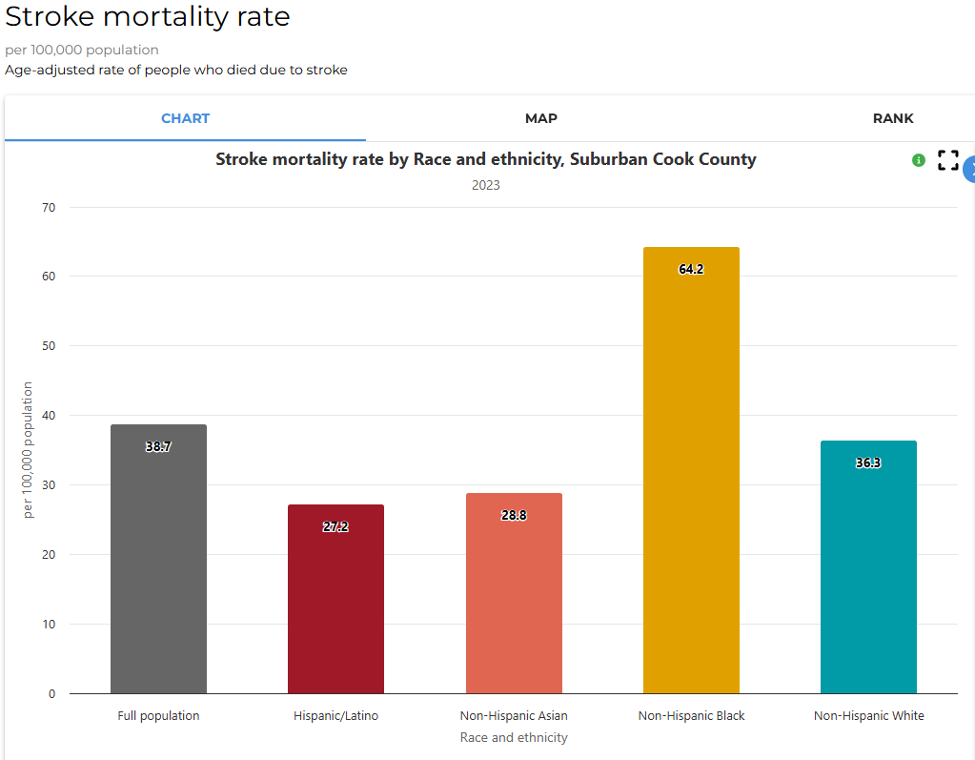

Jasmine then clicks to the “Line Chart” to see how stroke mortality has changed over time.
In 2020, stroke mortality rate among the Non-Hispanic Black population ___________from _______ to _______ then _________to _______in 2021.
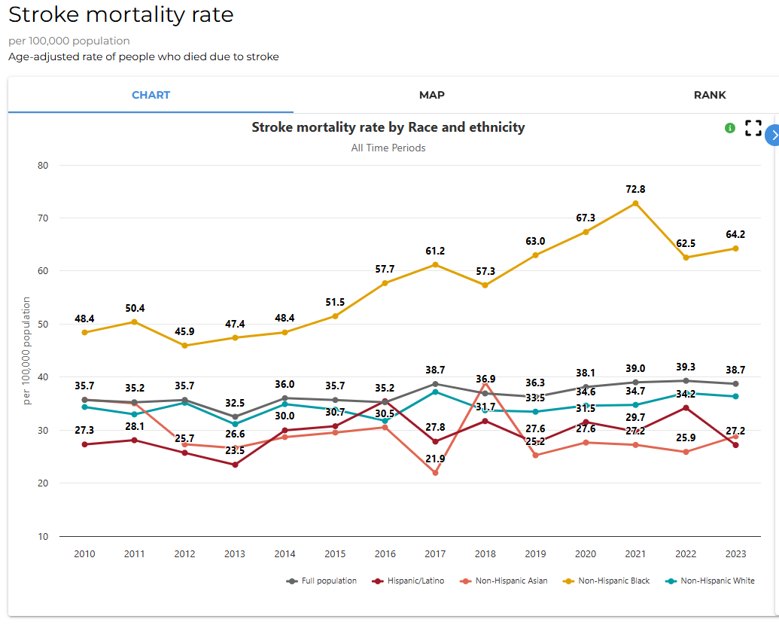

Then, Jasmine clicks to view a map and realizes that this indicator is visualized by municipalities. She notices that the highest burden of stroke is concentrated between the _________and _________region of suburban Cook County. She decides to promote Healthy Hearts programming in these areas.
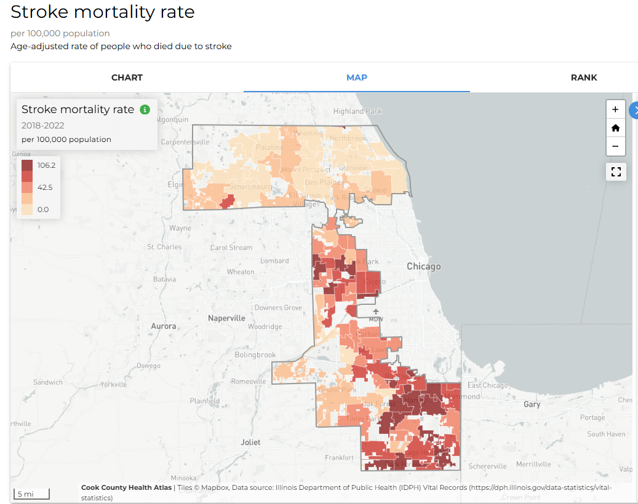

After looking at stroke mortality, Jasmine decides she wants to look at hospitalizations and see how they differ from stroke-related deaths.
She searches for stroke-related hospitalization rate and notices that the ___________population has a ________ per 100,000, and the whole population of suburban Cook County has ________ per 100,000.
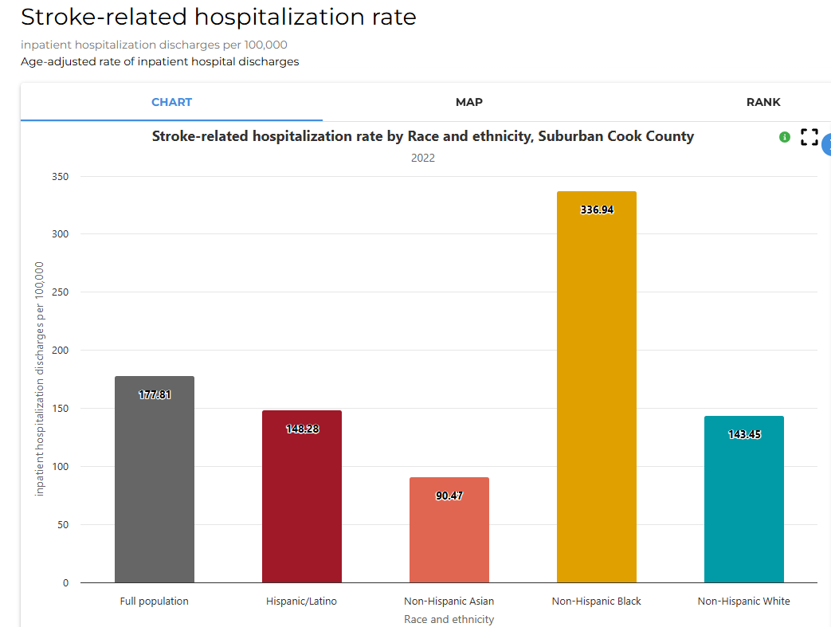

The Non-Hispanic Black population experiences stroke-related hospitalizations at a rate ___________(hint: divide the black population’s rate by the full population’s rate to find the rate ratio) times _______ than the full population of suburban Cook County.

Questions for Discussion:
- What did you find surprising about the data?
- Did you identify any disparities in the data? If yes, among which groups?
- How could this type of data support your work (i.e., programming, grant applications)?
- How could this data be helpful to make a case for an education campaign and programming for these organizations?

For more help with this activity, see a step-by-step tutorial here: Tutorial

