

Mike works as a SNAP Outreach Coordinator at ABC Social Services agency. He wants to know where to focus their SNAP outreach to find community members in ________________ who may be eligible but are not enrolled in the program.
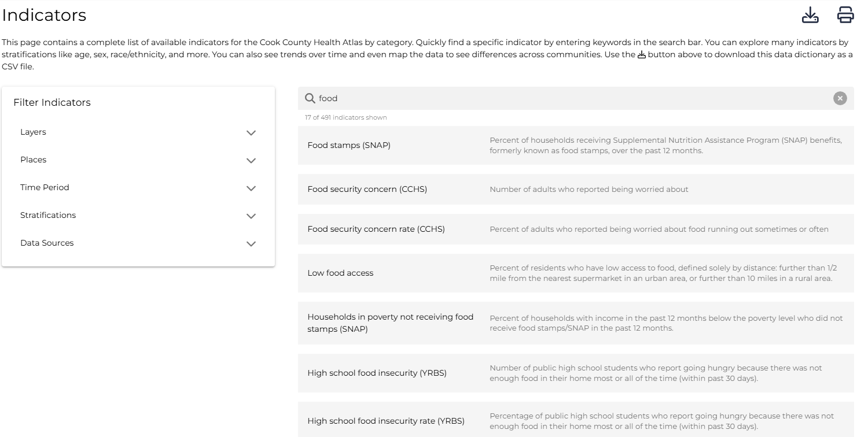
Mike searches the Cook County Health Atlas Data Dictionary for indicators related to food access and finds 7 different indicators to examine:

From this list of 7 indicators, he decides to narrow down his Atlas search to explore the 2 indicators related to SNAP/food stamps: “Food stamps (SNAP)” and “Households in poverty not receiving food stamps (SNAP).”
- Food stamps (SNAP) ✅
- Food security concern (CCHS)
- Food security concern rate (CCHS)
- Low food access
- Households in poverty not receiving food stamps (SNAP) ✅
- High school food insecurity (YRBS)
- High school food insecurity rate (YRBS)

First, Mike searches the Food stamps (SNAP) indicator and pulls up a bar chart of Food stamps (SNAP) by race in all of Suburban Cook County.

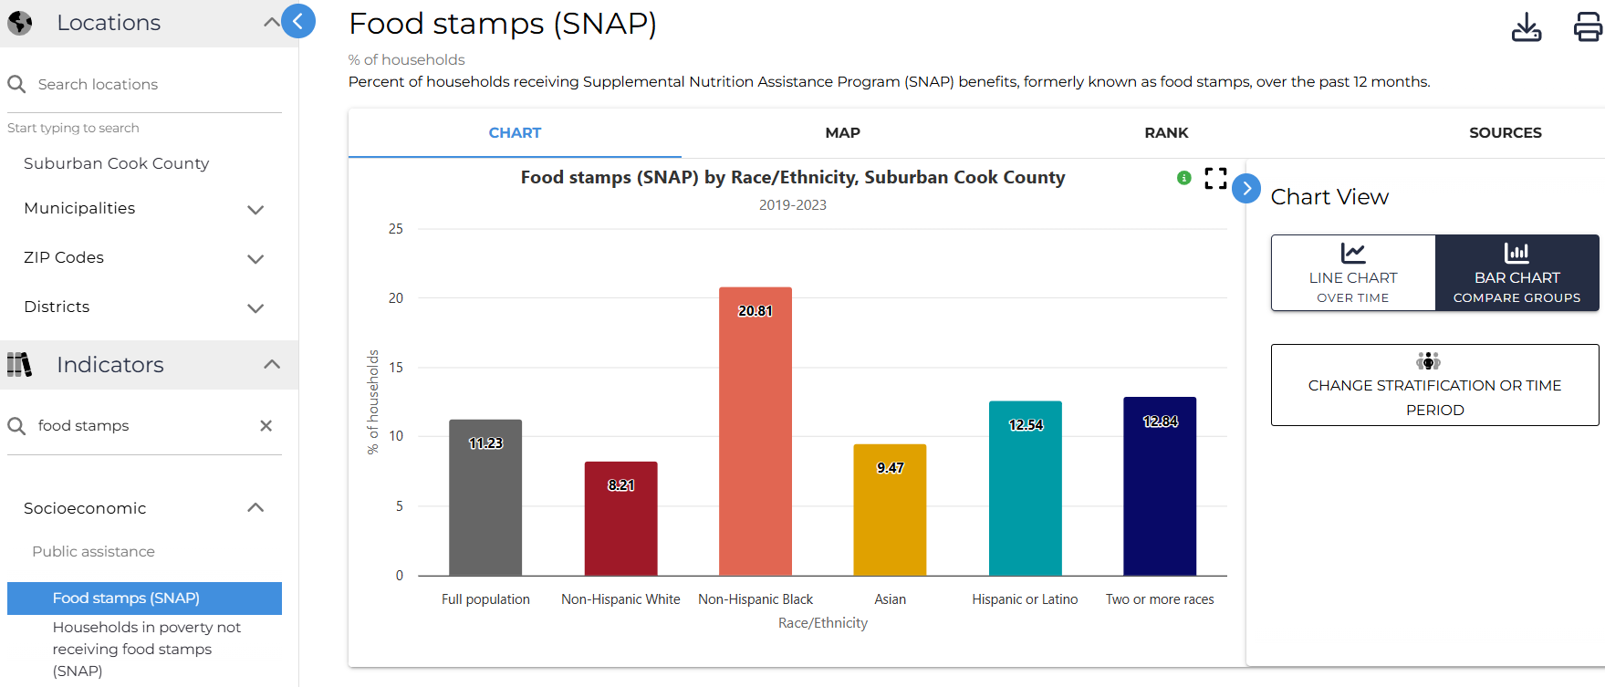

He notices that the ______________ population had the highest percentage of households receiving SNAP from __________________ while the ___________________ population had the lowest percentage.

Mike is also interested in how SNAP enrollment has changed over time, so he proceeds to click to the “Line Chart” options. He notices that the __________________ population has ________________ over time whereas the _________________ has ______________________ over time.

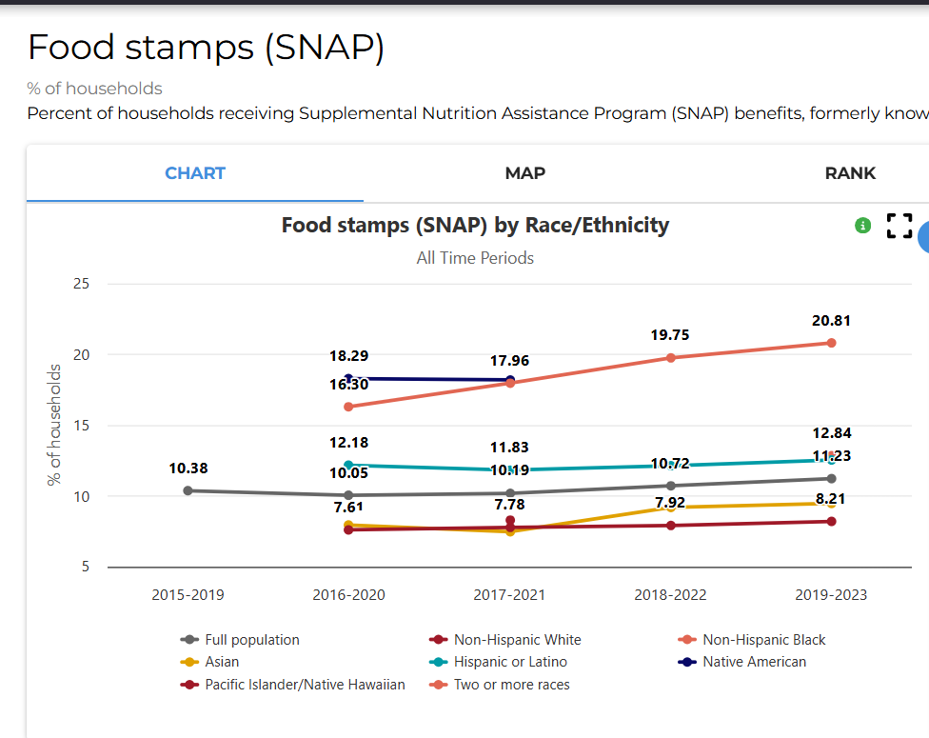

Next, Mike compares the percentage of ___________________ Households in poverty not receiving food stamps (SNAP) with all Suburban Cook County. He opens a map of Suburban Cook County that color codes each municipality.

Areas in red show the highest percentages, while areas in blue show the lowest percentages:

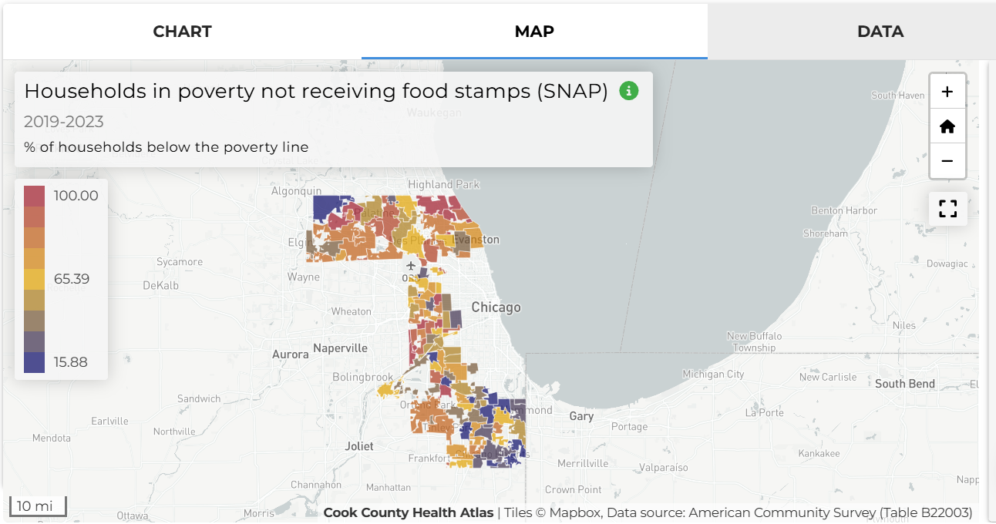

Mike observes that _____________ of households in _________________ were not enrolled in SNAP from _______________.

In comparison, the percentage of households in poverty not receiving SNAP in Suburban Cook County was _________ this time period. This shows a [% difference between Suburban Cook County and chosen municipality] _____________ percentage point difference between the two. Therefore, the SNAP enrollment for _________________ is _________________ in comparison to the general population in Suburban Cook County.

Mike clicks on ________________________ on the map to look at it more closely. The map then displays data at the census tract level for the municipality. In comparing census tracts, he sees some areas have an even higher percentage rate of Households in poverty not receiving food stamps while some have a lower percentage.
This data gives Mike insight into which neighborhoods to prioritize where he does his outreach. He considers the relationships he has with the neighborhood churches, schools, libraries, senior centers, and other agencies he can partner with to host an event that promotes food access in their community.

Questions for discussion:
- What did you find surprising about the data?
- Did you identify any disparities in the data? If yes, among which groups?
- How could this type of data support your work (i.e., programming, grant applications)?
- In this scenario, what other information could be useful for Mike to plan his SNAP outreach efforts?

For more help with this activity, see a step-by-step tutorial here: Tutorial

