

Sandra is a health care administrator on the Community Health team at a local safety net hospital. Every 3 years, the hospital convenes a multi-agency council to conduct a community health needs assessment, and Sandra is one of the project leads. She is tasked with analyzing data to include in the health care access section of the assessment. This section typically includes data regarding health insurance coverage and the availability of health care providers.
She searches the Cook County Health Atlas Data Dictionary for indicators related to health insurance and finds only 2 indicators to examine:

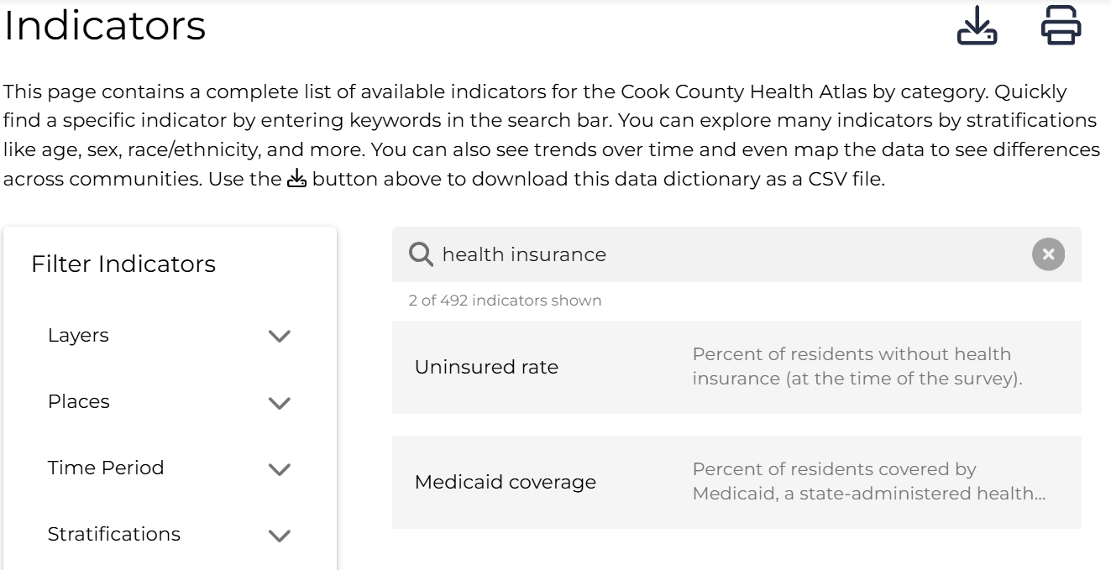

From this list of 2 indicators, she decides to explore both indicators: “Uninsured rate” and “Medicaid coverage”:
- Medicaid coverage ✅
- Uninsured rate ✅

First, Sandra searches the Medicaid coverage indicator and pulls up a bar chart of Medicaid coverage by age in all Suburban Cook County.
She notices that the ________________ population shows the highest percentage of residents enrolled in Medicaid from _________________ while the ________________ population had the lowest percentage.

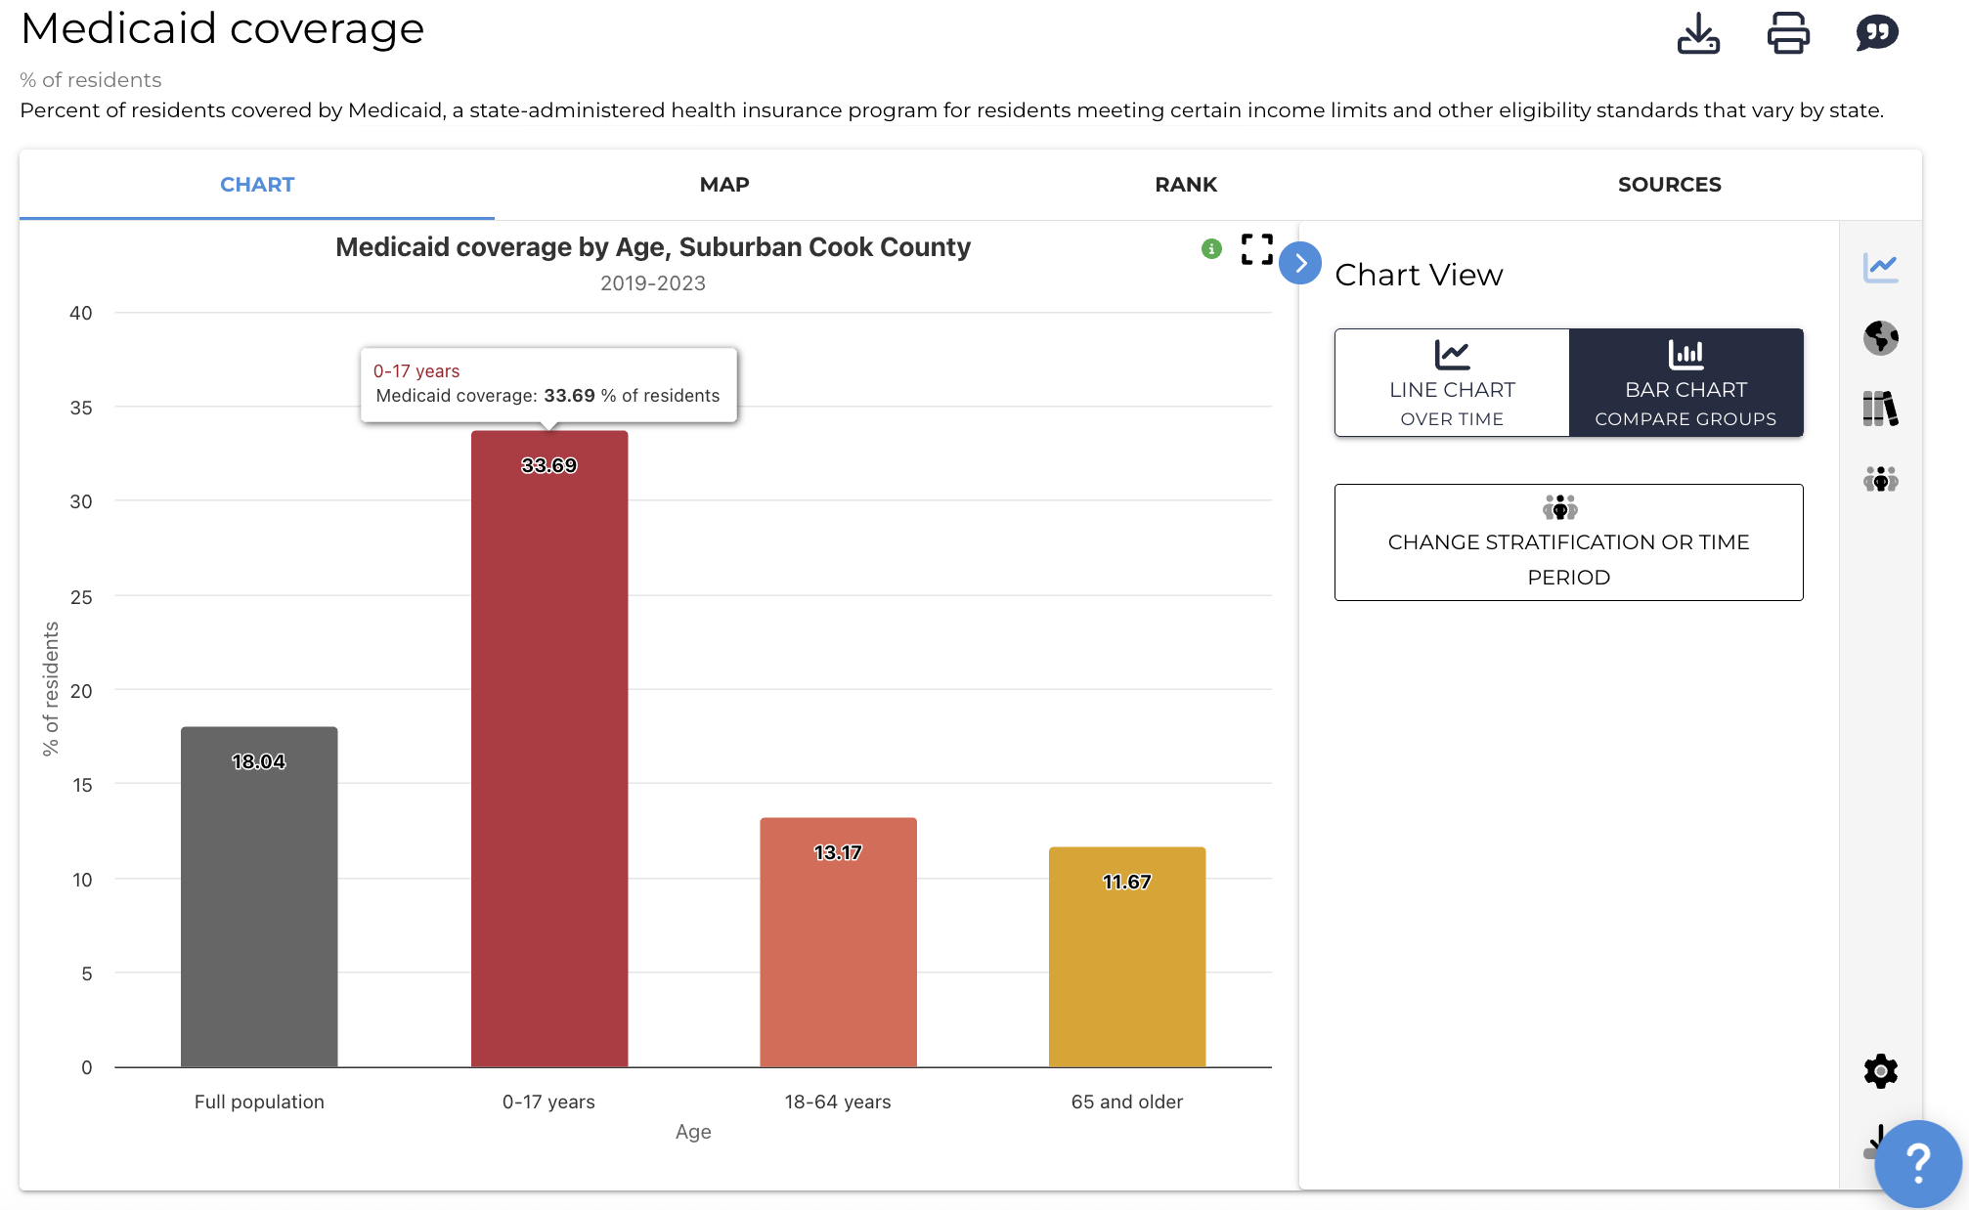

Next, Sandra compares the percentage of Medicaid coverage in ________________ with all Suburban Cook County. She opens a map of Suburban Cook County that color codes each municipality.
Areas in red show the highest percentages, while areas in blue show the lowest percentages:
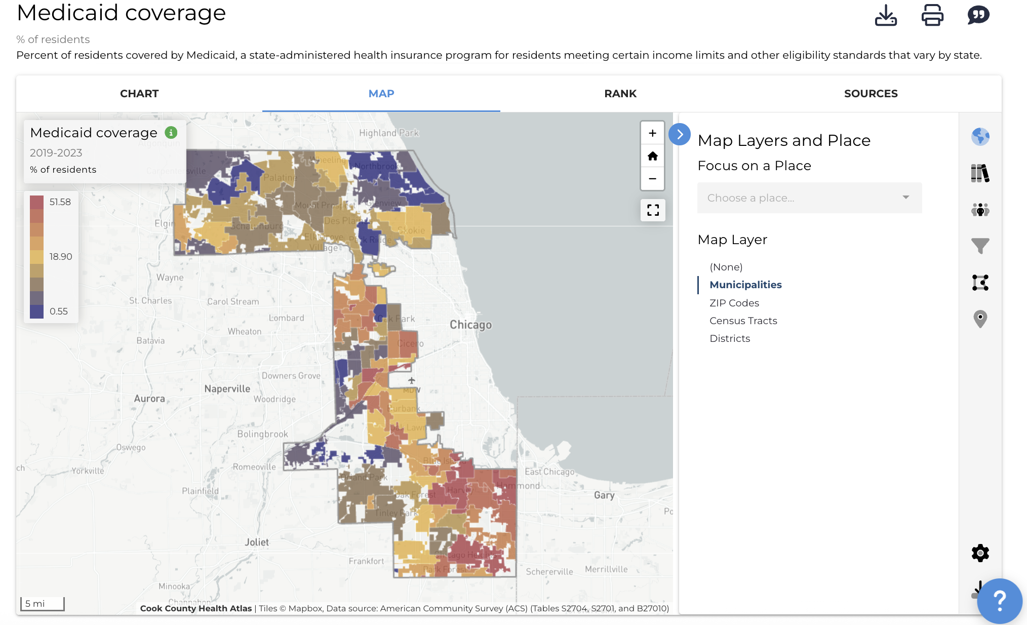

Sandra observes that _______________ of residents in __________________ were covered by Medicaid from ________________.
In comparison, the percentage of residents with Medicaid coverage in Suburban Cook County was _______________during this time period. This shows a ________________ percentage point difference between the two.
Therefore, Medicaid enrollment for _____________________ is __________________ than the general population in Suburban Cook County.

Next, Sandra wants to examine the Uninsured rate in ____________________.
This indicator is available by age group, providing valuable insight for her needs assessment. She pulls up a chart showing the difference between each age group in [name of municipality] and suburban Cook County.
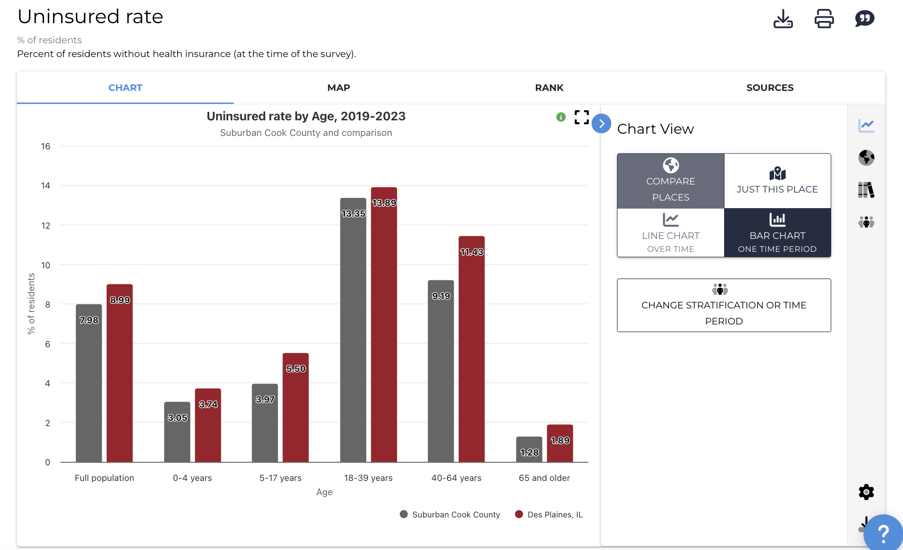

Sandra notices that the __________________ group has a ________________ uninsured rate in ______________________ compared to suburban Cook County.
This data gives Sandra insight into which age groups in _______________________ may be disproportionately uninsured, helping her identify populations that could benefit from targeted outreach and resources.

After studying the Medicaid coverage and uninsured populations, Sandra decides she wants to better understand access to primary care providers. She searches the primary care provider rate in ________________________ and compares it to other Cook County municipalities.
Sandra switches to the primary care provider rate indicator and then clicks on Map.
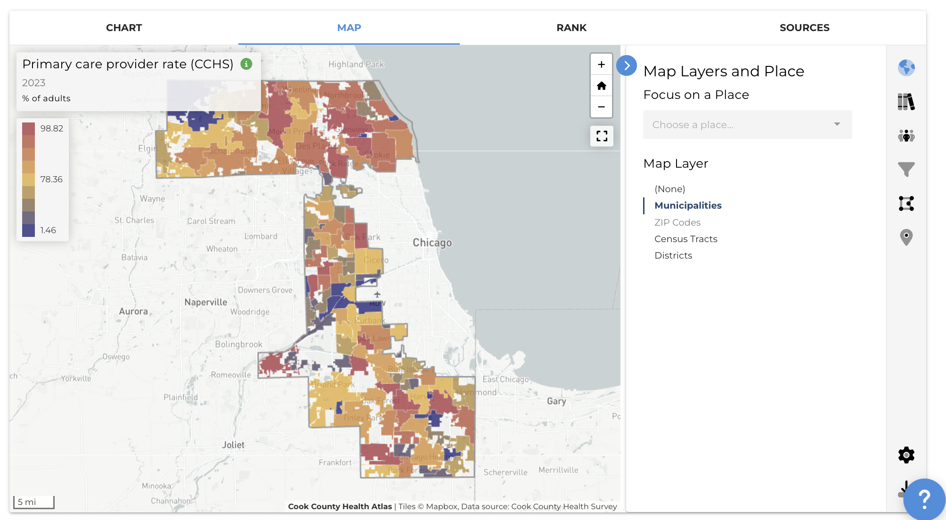

She notices that _______________________ has a __________________ Primary care provider rate compared to neighboring municipalities.

Next, Sandra pulls up a bar chart of the primary care provider rate by race/ethnicity for 2023.
She observes that the _____________________ population had the highest primary care provider rate in 2023, while the ____________________ population had the lowest primary care provider rate in 2023.
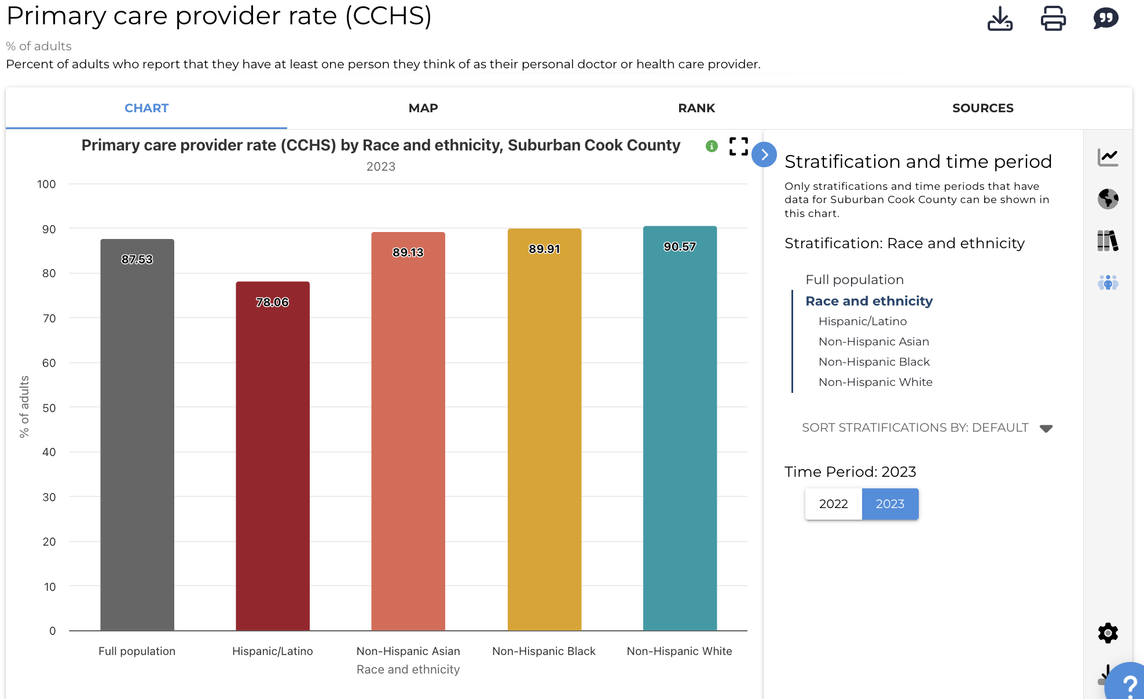

This data gives Sandra insight into local needs versus countywide trends, which supports stronger recommendations for resource allocation in the community health needs assessment.

Questions for discussion:
- What did you find surprising about the data?
- Did you identify any disparities in the data? If yes, among which groups?
- How could this type of data support your work (i.e., programming, grant applications)?
- In this scenario, what other information could be useful for Sandra to plan her community needs assessment?

For more help with this activity, see a step-by-step tutorial here: Tutorial

